

Asbestos Register and Management Plan: West Wyalong

This document lists all the buildings and the asbestos that they currently contain for West Wyalong Presbyterian church and its outstations. It should be presented to any contractors before they start work on any of the buildings with asbestos.
The document also details when the last inspections were, when the next inspections need to be made and what the plan for the asbestos is – maintaining it in good condition or removal.

Inspections
The initial inspection was done by Jim Brooks of Jim Brooks Constructions Pty Ltd, a registered asbestos removal company with a class B license no AD210185 in August 2018. The condition of the areas of asbestos will be checked each year by a competent member of the church and any issues highlighted and dealt with as appropriate. Every five years the areas of asbestos will be checked by a qualified person.

Place | Inspection by External Person |  | Checks by church
 | Date | Next Date Due | Date | Next Date Due
Church | 15/8/2018 | n/a | n/a | n/a
Manse | 15/8/2018 | 15/8/2023 | n/a | 15/8/2022
Hall | 15/8/2018 | 15/8/2023 | n/a | 15/8/2022
Barmedman | 17/8/2018 | 17/8/2023 | n/a | Sold
Tallimba | 17/8/2018 | 17/8/2023 | n/a | Sold
Weethalle | 17/8/2018 | n/a | n/a | n/a

Given no asbestos was found in the church and at Weethalle, there is no reason for further inspections.

Asbestos Register
Date of Identification | Type of Asbestos | Friable/Non-friable | Condition | Specific Location of Asbestos | Is the asbestos in an accessible area? | Action Needed/ Completed | Last Inspection Date
 |  |  |  | (all areas are approximate)
Church
None
Hall
15/8/2018 | Wall Cladding | Non-Friable | Generally good except small area of one sheet needs attention. | Room including toilet and basin off kitchen.  All walls and asbestos, including toilet dividers on both sides.  Walls ~ 20 m²  Dividers ~ 14 m² | Yes but if action taken unlikely to be damaged | Unibond small area on surface completed. | 17/8/2021
15/8/2018 | Ceiling | Non-Friable | Good | Room including toilet and basin off kitchen.  Office ~ 9m² | No | None required | 17/8/2021
15/8/2018 | Wall Cladding | Non-Friable | Good | Office ~ 26 m² | Yes | None required | 17/8/2021
15/8/2018 | Ceiling | Non-Friable | Good | Office~ 11m² | No | None required | 17/8/2021
15/8/2018 | Electric Box | Non-Friable | Good | At west end of hall outside of building | Yes | None required | 17/8/2021
Manse
15/8/2018 | Wall Cladding | Non-Friable | Good | Main Bathroom all wall cladding  ~15 m² | Yes | Removed 28/11/2018 | n/a
15/8/2018 | Outside cladding | Non-Friable | Good | Board underneath window at back of Manse  ~4 m² | Yes | None required | 17/8/2021
15/8/2018 | Outside cladding  (possible so listed). Rechecked and not asbestos. | Non-Friable | Good | Front left hand side of verandah, outside wall of ensuite ~2.3 m² | Yes | None required
15/8/2018 | Electric Box | Non-Friable | Good | East side of Manse at front on outside. | Yes | None required | 17/8/2021
Tallimba – Sold May 2021
17/8/2018 | Electric Box | Non-Friable | Good | Railway side of church | Yes | None required | n/a
17/8/2018 | Outside cladding | Non-Friable | Good | All of the outside:  ~105 m² | Yes | None required | n/a
Barmedman – Sold December 2021
17/8/2018 | Ceiling | Non-Friable | Good | Entrance ~9 m² | No | None required | n/a
17/8/2018 | Ceiling | Non-Friable | Good | Vestry ~12 m² | No | None required | n/a
17/8/2018 | Ceiling | Non-Friable | Good | Main church ~165 m² | No | None required | n/a
17/8/2018 | Eaves | Non-Friable | Good | Eaves ~42 m² | No | None required | n/a
17/8/2018 | Electric Box | Non-Friable | Good | Southside of Building | Yes | None required | n/a
Weethalle
None

Pictures of Asbestos

Manse

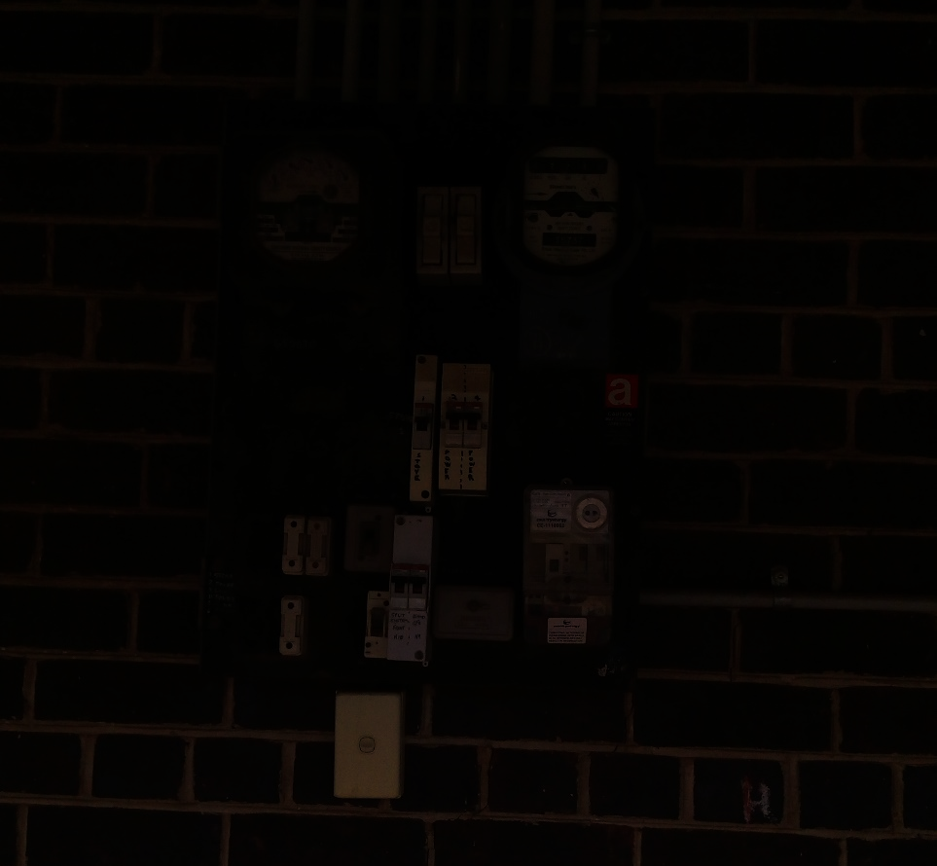
The electricity board on the left hand side of the Manse consists of asbestos.
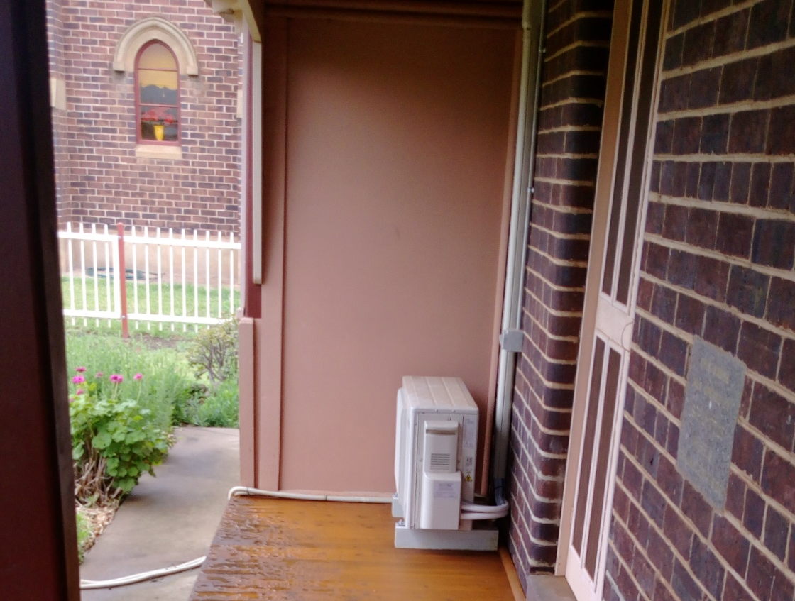
The outside sheet at end of manse that is part of the wall of the ensuite is possibly asbestos.
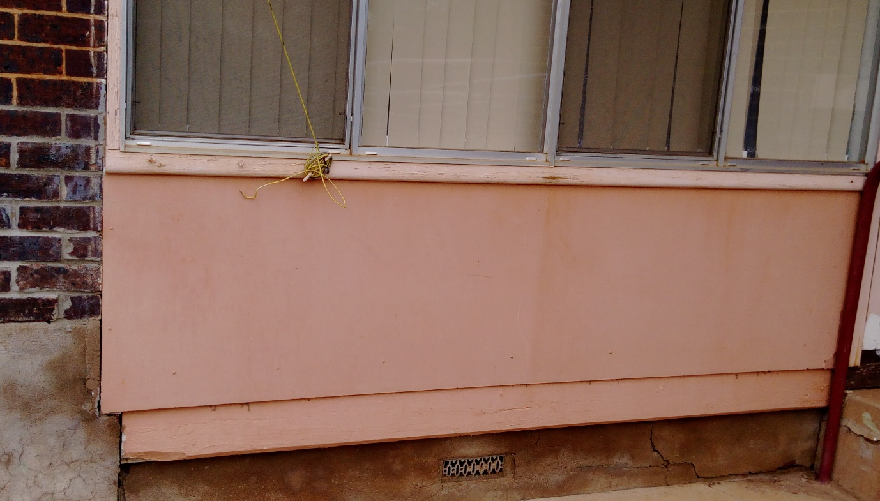
The sheet beneath the window at the back of the Manse is possibly asbestos.

Hall
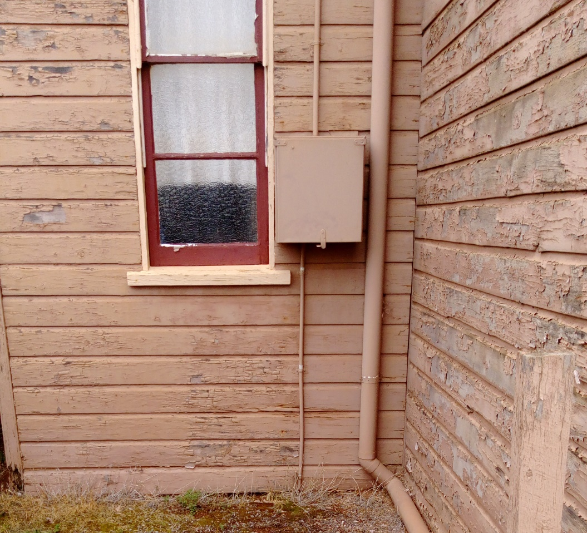
The electricity board on the west side of the hall is asbestos.
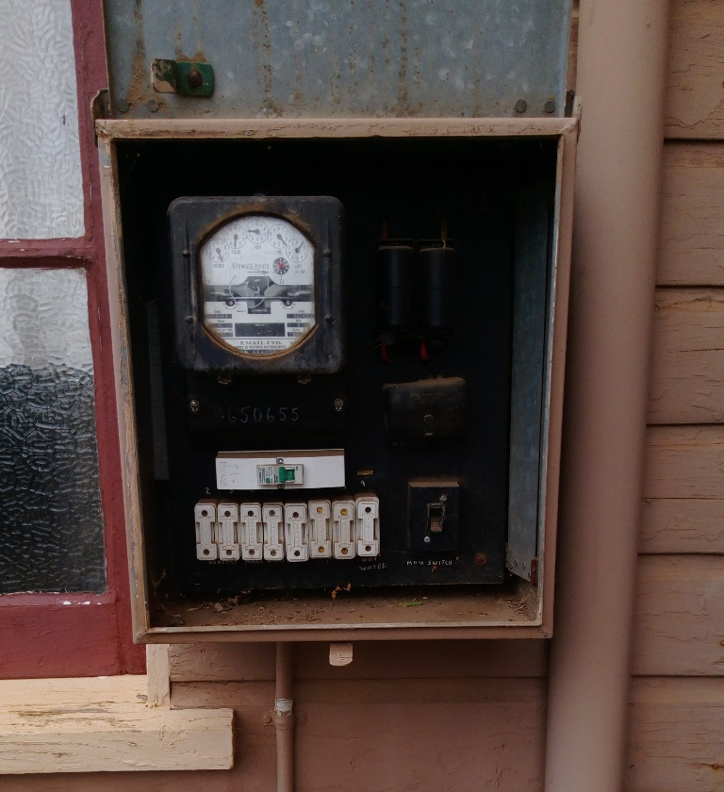
The inside of the electricity box showing the asbestos.
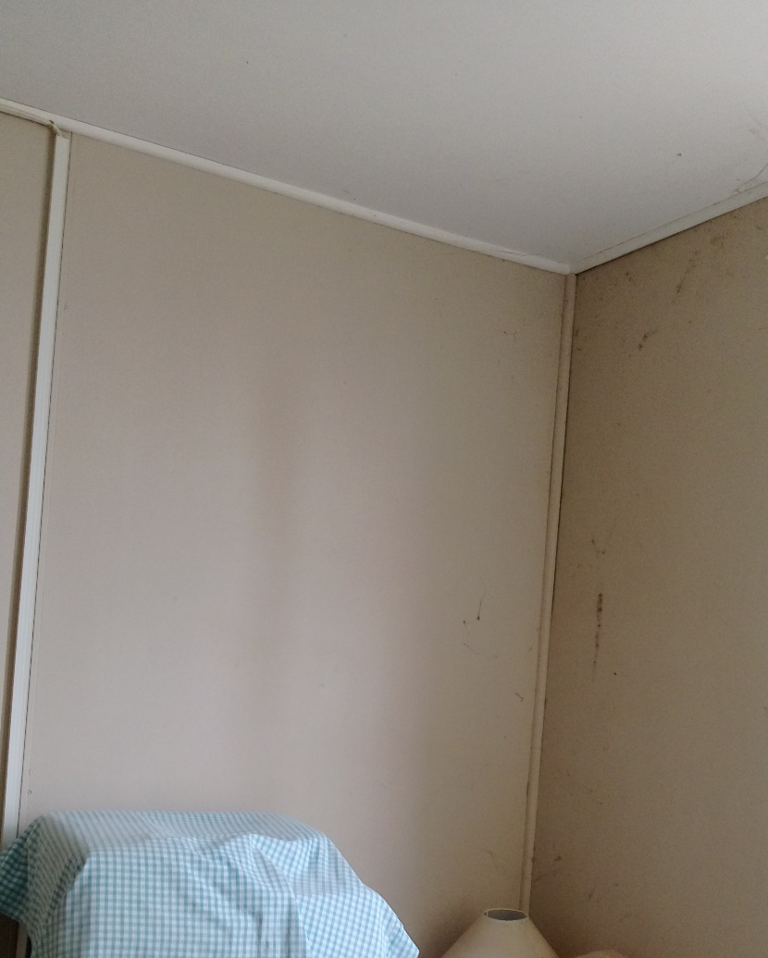
The wall claddings and the ceiling in the office is asbestos.
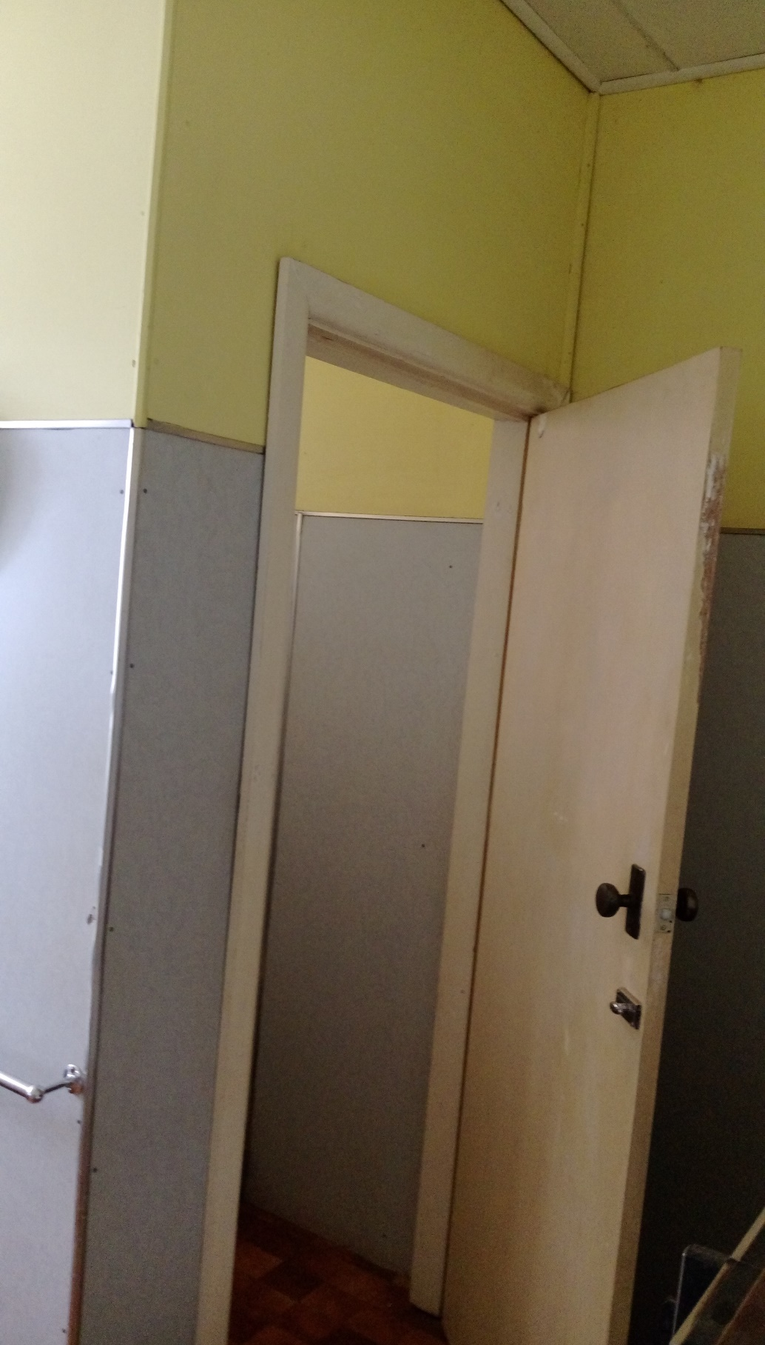
In the area where there are toiletry facilities, all the wall cladding and ceiling has asbestos. This includes both sides of the dividers around the toilets.
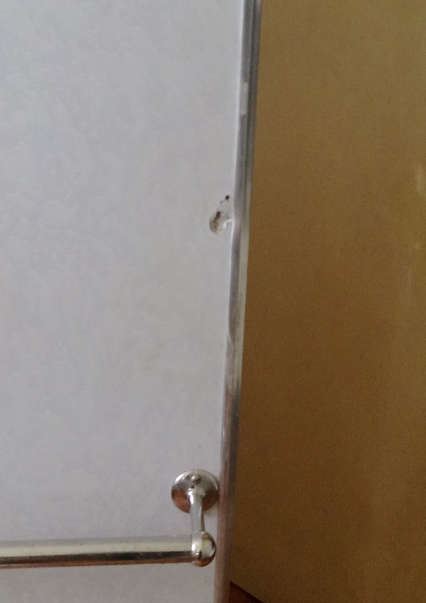
The small area of asbestos that was damaged. The photograph shows the area after it was unibonded.

Barmedman
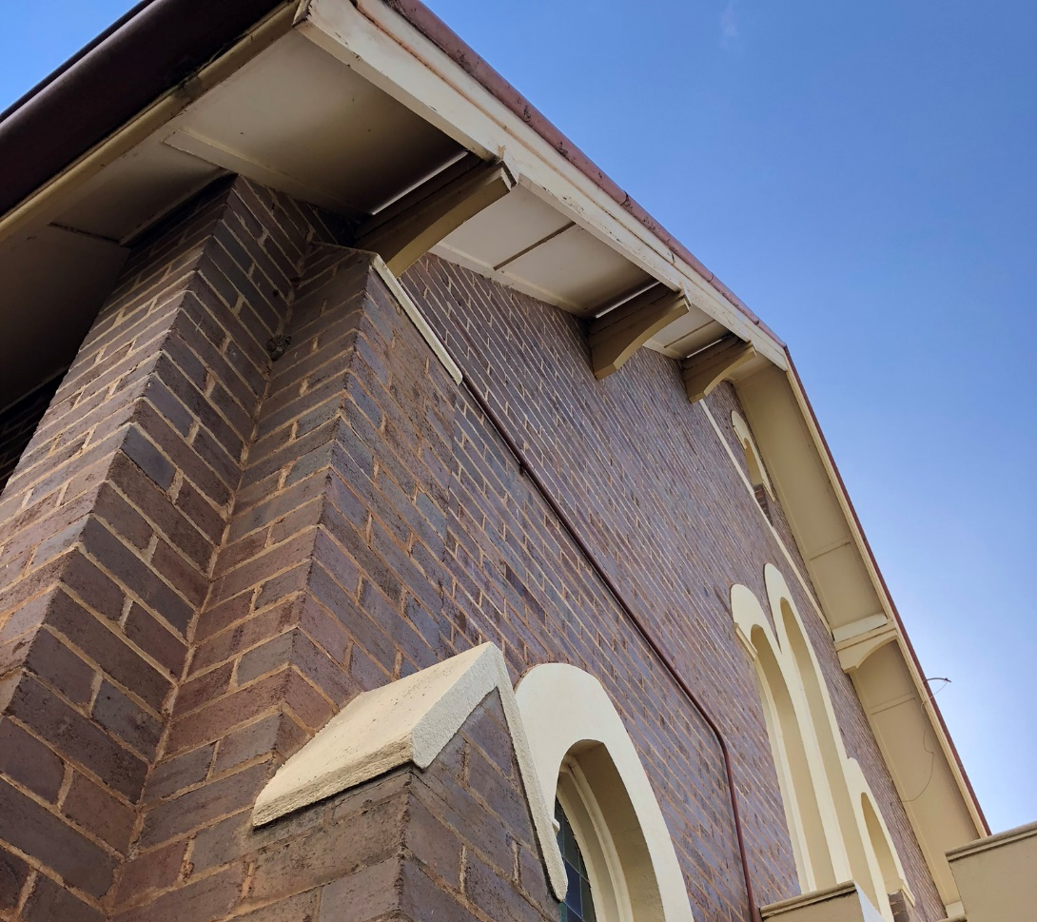
The front eaves of the church are asbestos. All the eaves and ceilings are also asbestos.

Tallimba
All the outside wall cladding is asbestos.
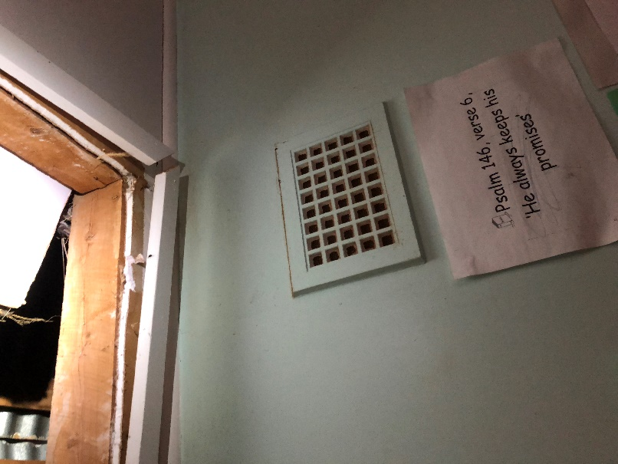
The inside is giprock and not asbestos. The ceiling (above) and the walls (below) were checked.
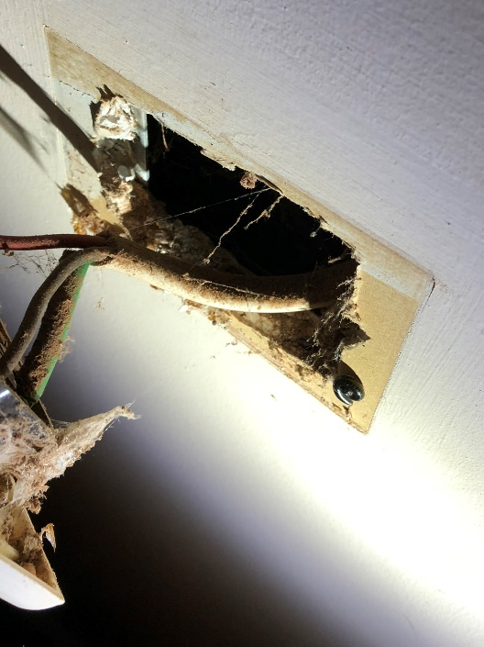

Inspection Register:

The first inspection of the church, hall and manse was done on 15th August 2018 and all areas of potential asbestos checked and recorded. The first inspection of the outstations was done on 17th August and all areas of potential asbestos checked and recorded in the asbestos register

Person doing Inspection: Jim Brooks

Signature:

Date:

Asbestos Management Plan
Asbestos will be removed when either building projects touch the affected area or it becomes hazardous. Any other areas with asbestos will be inspected annually by members of the congregation. Every five years they will be inspected by a qualified person. These inspections will be recorded.

If any damage to asbestos is found then this will either be made safe or removed by approved people and such actions recorded in the register.
- The area will be marked as a no go area until the problem is resolved.
- Properly painted to seal all asbestos. Any breaks of the seal will immediately be appropriately resealed or the asbestos removed.
- In either case the asbestos will be reinspected after the work is done

Asbestos affects people working on the site:
- Any builders working on the site will be formally shown the asbestos register.
- In the case of sale where the asbestos has not been removed, the purchaser will be informed of the presence of asbestos.

Date of Inspection | Person Inspecting | Issues Found | Action Needed/ Completed | Date when Work done | Date when successfully reinspected | Next Inspection | Next Five Year (external) Inspection
Hall
15/8/2020 | Andrew Cooper | None |  | n/a | n/a | 15/8/2021 | 15/8/2023
15/8/2019 | Andrew Cooper | None |  | n/a | n/a | 15/8/2020 | 15/8/2023
Manse
15/8/2020 | Andrew Cooper | None |  | n/a | n/a | 15/8/2021 | 15/8/2023
15/8/2019 | Andrew Cooper | None |  | n/a | n/a | 15/8/2020 | 15/8/2023
Tallimba
20/10/2020 | Andrew Cooper | Eaves dropping | Work left for new buyer after seeing what can be done easily and safely | 27/10/20 | n/a | 20/10/2021 | 15/8/2023
1/11/2019 | Andrew Cooper | None |  | n/a | n/a | 1/11/2020 | 15/8/2023
Barmedman
20/11/2020 | Andrew Cooper | See below for ceiling |  | n/a | n/a | 20/11/2021 | 15/8/2023
4/10/2019 | Andrew Cooper | Leakage in front hall area going immediation on to asbestos so paint coming off asbestos. | Front roof inspected and gutters cleaned. | 15/11/2019 | 02/04/2020 | 15/11/2020 | 15/8/2023
 | Andrew Cooper | Gap between eaves and roof on vestry where birds were likely to start going in. If not dealt with birds might cause asbestos to come out. | Nailed back on | 15/11/2019 | 12/12/2019
 | Andrew Cooper | Gap in ceiling of main church where one panel has come away from another. No immediate danger but as panels are asbestos am noting it. | n/a. | n/a | n/a

