Workplace Emergency Plan

To ensure compliance with

SafeWork NSW requirements
Work Health and Safety Act 2011
Work Health and Safety Regulation 2017
AS 3745 Planning for Emergencies in Facilities

Additional Procedures

If you need to add additional procedures such as Bushfire Procedures or other items, please contact Fire Support NSW.

Training

Emergency Procedures/Fire Warden training is available for your site. Please contact either:

- NSW Head Office: general@pcnsw.org.au

- Fire Support NSW: info@firesupport.com.au

Created by

Timothy Wainwright
Director of Fire Safety & Training
Fire Support NSW

M: 0413 229 347
E: info@firesupport.com.au
W: www.firesupport.com.au

Revision History

Date | Version | Comments
14/08/2025 | V1.0 | Original document. Review in 2 years (14/08/2027) or sooner if required.

Emergency Planning Committee Members:

Name | Title | Contact Details
 | Senior Minister | E:  M:
 | WHS Manager | E:  M:
 | Chief Warden | E:  M:
E:
M:
E:
M:
E:
M:
E:
M:

Scope and application of the Emergency Plan

This Emergency Plan is designed to prepare for and respond to various emergency incidents including:

- Fire (If applicable, please seek assistance to add Bushfire Procedures)
- Medical emergencies (e.g. injuries, illnesses, or COVID-19 or other infectious outbreaks)
- Bomb threats and suspicious packages
- Violent or threatening behaviour (personal threats or security breaches)
- Chemical spills/hazardous material incidents
- Power outages
- Natural disasters such as storms and flooding
- Environmental incidents

Specific Scenario Example:
If a staff member or visitor is diagnosed with COVID-19, the plan includes protocols for isolation, notifying health authorities, contact tracing, and sanitization procedures to prevent further spread within the premises.

Activation of the Emergency Plan
The emergency plan is activated upon the detection or notification of an emergency event. This could occur through:
- An alarm (e.g., smoke alarm, siren)
- A staff member or designated personnel recognizing a situation and initiating the response
- External alerts or notifications (e.g., emergency services advising action)

Once activated, designated staff members will implement response procedures, including evacuation, lockdown, or seeking medical or external assistance as appropriate.

Emergency contacts

Contact | Name | Phone number
Emergency services – triple zero | Fire/Police/Ambulance | 000
Police | Insert Here | Insert Here
Fire and Rescue NSW | Insert Here | Insert Here
NSW Rural Fire Service | Insert Here | Insert Here
Ambulance | Insert Here | Insert Here
Hospital - Adults | Insert Here | Insert Here
Hospital - Children | Insert Here | Insert Here
Medical Centre | Insert Here | Insert Here
Chemist | Insert Here | Insert Here
Poison information line | Poison information line | 13 11 26
State Emergency Services (SES) | YOUR LOCATION NSW SES | 13 25 00
Chief Warden | Insert Here | Insert Here
Fire Warden (Church) | Insert Here | Insert Here
Fire Warden (Children’s Church) | Insert Here | Insert Here
Communications Officer | Insert Here | Insert Here
First aid officer 1 | Insert Here | Insert Here
First aid officer 2 | Insert Here | Insert Here
Mobility Assistance Officer | Insert Here | Insert Here
WHS officer | Insert Here | Insert Here
Nearby business/neighbour | Insert Here | Insert Here
Nearby business/neighbour | Insert Here | Insert Here
Nearby business/neighbour | Insert Here | Insert Here
Nearby business/neighbour | Insert Here | Insert Here
Water | Insert Here | Insert Here
Electricity | Insert Here | Insert Here
Gas | Insert Here | Insert Here
Internet | Insert Here | Insert Here
COVID-19 information lines | COVID-19 information lines | 1800 020 080
NSW Department of Health (Public Health Unit) | For Communicable Disease Reporting | 1300 066 055

Emergency Control Organisation - roles and responsibilities

Chief Warden | White Helmet
Insert Name Here
Reasoning:
It is decided by the management committee that INSERT HERE is a “Competent Person” in accordance with AS3745 and will be the appointed as Chief Warden.
Duties: Pre-Emergency
Obtain Fire Warden training and maintain skills. Be proficient with the emergency procedures and instruct all staff on the procedures including evacuation procedures, wardens, first aid, location of exits, location of assembly area, location of and how to use emergency equipment (extinguishers etc) and other types of emergencies.
Duties: In an Emergency
Take charge of the initial emergency response and facilitate either the containment of the emergency/fire or other emergency, and/or the safe evacuation of all staff in the event of an emergency and to ensure all staff are accounted for at the assembly area.
Liaise with all levels of the organisation and with authorities.
When appropriate, give the all-clear and assist with the return to normal business operations.
Duties: After an Emergency
Debrief with all staff and emergency services if appropriate.
Return and replace emergency equipment and items as required.
Arrange for refilling or replacement of fire extinguishers.
Complete an after-action report and submit records of the emergency to the EPC.
Debrief with the EPC and implement any findings as appropriate.

Church Warden (Also Deputy Chief Warden if required) | Red Helmet
Insert Name Here
Reasoning:
The size of morning services requires a warden to allow for the effective response to emergencies and safe evacuation of all staff and to allow the Chief Warden to better control the emergency and or evacuation.
Duties: Pre-Emergency
Obtain Fire Warden training and maintain skills.
Be proficient with the emergency procedures, emergency equipment and assembly area.
Duties: In an Emergency
Respond to and contain small workplace emergencies.
Facilitate the safe evacuation of all attendees to the assembly area.
Ensure all attendees are accounted for and report to Chief Warden.
Duties: After an Emergency
Participate in staff debrief and with emergency services if appropriate.
Return and replace emergency equipment and items as required.
Arrange for refilling or replacement of fire extinguishers.
Complete an after-action report and submit records of the emergency to the Chief Warden.

Emergency Control Organisation - roles and responsibilities

Children’s Church Warden | Red Helmet
Insert Name Here
Reasoning:
The Children’s Church requires a warden to allow for the effective response to emergencies and safe evacuation of all children and staff and to allow the Chief Warden to control the emergency evacuation.
Duties: Pre-Emergency
Obtain Fire Warden training and maintain skills.
Be proficient with the emergency procedures, emergency equipment and assembly area.
Duties: In an Emergency
Respond to and contain small workplace emergencies.
Facilitate the safe evacuation of all staff to the assembly area.
Ensure all employees are accounted for and report to Chief Warden.
Duties: After an Emergency
Participate in staff debrief and with emergency services if appropriate.
Return and replace emergency equipment and items as required.
Arrange for refilling or replacement of fire extinguishers.
Complete an after-action report and submit records of the emergency to the Chief Warden.

Communications Officer | White Helmet
Insert Name Here
Reasoning:
Records of emergency events and actions taken must be recorded.
Duties: Pre-Emergency
Attend Fire Warden or ECO/EPC meetings to familiarise with roles and responsibilities and maintain those skills.
Be proficient with the emergency procedures, emergency equipment and assembly area.
Duties: In an Emergency
Activate the PA system to give the Evacuation Signal.
Manage all communications. Accurately record all events and times during the emergency including the roll-call of names at the Assembly Area.
Duties: After an Emergency
Participate in staff debrief and with emergency services if appropriate.
Accurately record all items and questions/concerns raised in the debrief.
Save and file all records of the emergency incident and make these available to the Chief Warden.

First Aid Officer 1 | Green Helmet
Insert Name Here
Reasoning:
A person trained in First Aid must be present.
Duties: Pre-Emergency
Attend an approved first aid course and maintain currency.
Know the location of the First Aid Kit and maintain the contents.
Be aware of any staff medical requirements, locations and storage requirements of medications.
Be aware of how to contact relevant emergency services.
Duties: In an Emergency
Be able to respond to all medical emergencies and be able to contact emergency services.
Accurately record all events and times during the emergency.
Liaise with attending emergency services (patient hand-over).
Duties: After an Emergency
Participate in staff debrief and with emergency services if appropriate.
Restock first aid supplies, clean and restow emergency equipment as required.
Complete all medical records and report to the Chief Warden.

Emergency Control Organisation - roles and responsibilities

First Aid Officer 2 | Green Helmet
Insert Name Here
Reasoning:
A person trained in First Aid must be present.
Duties: Pre-Emergency
Attend an approved first aid course and maintain currency.
Know the location of the First Aid Kit and maintain the contents.
Be aware of any staff medical requirements, locations and storage requirements of medications.
Be aware of how to contact relevant emergency services.
Duties: In an Emergency
Be able to respond to all medical emergencies and be able to contact emergency services.
Accurately record all events and times during the emergency.
Liaise with attending emergency services (patient hand-over).
Duties: After an Emergency
Participate in staff debrief and with emergency services if appropriate.
Restock first aid supplies, clean and restow emergency equipment as required.
Complete all medical records and report to the Chief Warden.

Note: It is recommended that a second and even third person hold a first aid qualification to ensure coverage is kept if the main first aid officer is not at the site.

Mobility Assistance Officer
Insert Name Here
Reasoning:
Some attendees either use a wheelchair and/or may require special assistance during an emergency/evacuation. Therefore, it is recommended that one or more suitable people be appointed to provide this assistance in an emergency.
Duties: Pre-Emergency
Discuss with appointees, what assistance is required and conduct a walk-through of the process that is required to go from the office to the Assembly Area to ensure this is practicable and safe in the event of an emergency.
Duties: In an Emergency
Be able to respond to all medical emergencies and be able to contact emergency services.
Accurately record all events and times during the emergency.
Liaise with attending emergency services (patient hand-over).
Duties: After an Emergency
Participate in staff debrief and with emergency services if appropriate.
Restock first aid supplies, clean and restow emergency equipment as required.
Complete all medical records and report to the Chief Warden.

Note: It is recommended that a second or third person be appointed to this role in case the primary person is not on site during an emergency.
It may be that the First Aid officer/s may render this assistance if required.
As a last resort, the Church Warden will provide this assistance.

Site Details

EMERGENCY SIGNALS
P.A. System (Hand Held)

Evacuation/Alert Signal:
Primary: Public Address system (hand-held) is to be used to alert occupants of an evacuation by the words:

“Evacuate, Evacuate, Evacuate.
Please proceed to the Assembly Area.
Evacuate, Evacuate, Evacuate.
Please proceed to the Assembly Area.”

Back-up: Back-up: The back-up audible alarm shall be via Air-horn with three blasts repeated until all staff are evacuated.
Note:
When music/singing or other audio equipment is being used, the system shall be shut down to allow for the evacuation. The Warden shall personally inform occupants in that area of the emergency as they may not hear the audible alerts due to noise.

ASSEMBLY AREA &
EMERGENCY CONTROL POINT
Location where everyone evacuates to

PRIMARY LOCATION
On grass verge at front of premises/carpark
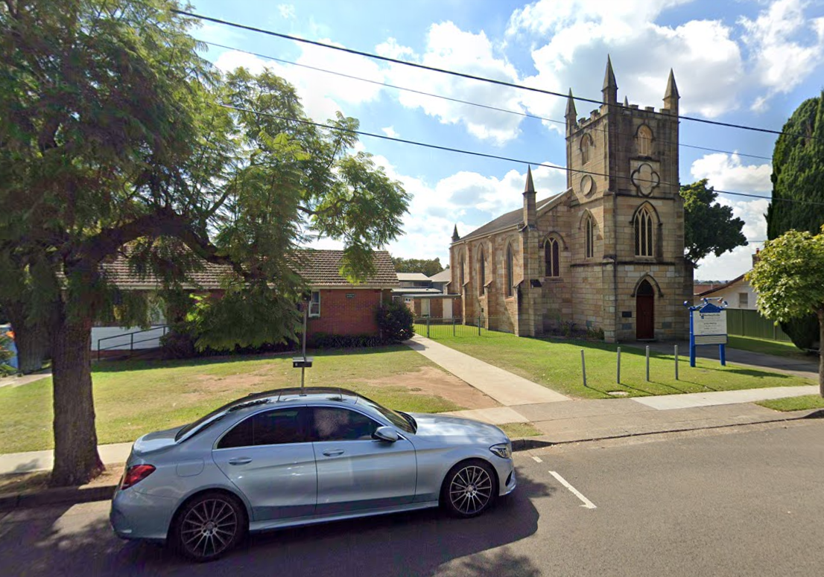
Alternate Location:
If conditions such as smoke or firefighter access exclude this space from providing a safe or effective Emergency Control Point/Assembly Area, the next location shall be in the park 50m to East of premises.

Site Details

Emergency Control Point & Assembly Area (continued):

Conditions: Subject to emergency conditions, an initial Emergency Control Point shall be located adjacent to the main business entrance, outside of the premises. This is the location where the Chief Warden will coordinate the emergency response and liaise with emergency services. (In most cases this location will also serve as the Evacuation Assembly Area, where all evacuated staff and visitors shall gather to be accounted for.

Alternate Location: Should conditions exclude this space from being a safe or effective Emergency Control Point/Assembly Area, the next location shall be 50m to the East at the park. Emergency services may move you to another location.

SPECIAL CONSIDERATION
Wheelchair/Mobility Assistance

PRIMARY LOCATION
Church

DETAILS
Some attendees use a wheelchair or may require assistance in the event of an emergency.

The appointed Mobility Assistance Officer shall be responsible for ensuring occupants requiring assistance are assisted to the Assembly Area. If the Mobility Assistance Officer is not available, then the First Aid Officers or Church Warden shall arrange for this to be done.

All staff should be aware of this and be ready to assist if required.

LOCAL DEMOGRAPHICS
Be aware that the wider area accommodates a lower socio-economic population, with poverty on the rise, and an abundance of social housing.

POTENTIAL ISSUES
Violent/Aggressive offender/antisocial behaviour, robberies and theft may occur.
Medical emergencies such as overdose may occur.

DETAILS
Be aware that some emergencies may come from members of the public and we need to be able to deal with these emergencies and keep everyone safe at work.

BUSH FIRES
The local area is NOT prone to bushfires.

POTENTIAL ISSUES
No Bushfire threat except for smoke in times of extreme regional fires.

DETAILS
NO Burning-ember issues. Bush Fire Procedures are not contained in this WEP
If you require Bushfire Procedures contact: info@firesupport.com.au

Emergency response procedures

FIRE
R.A.C.E.

R - REMOVE
Remove People from Danger  (Get people away from the danger and begin the evacuation process) | 
A - ALARM
Raise the Alarm  Alert those nearby to the danger. Activate Alarm if installed. Initiate Evacuation.  Notify Wardens/Office and call “000” Fire Brigade. | 
C - CONTAIN
Contain the Fire & Smoke  Close doors and windows if this action does not impede the evacuation of others, if this is safe to do so and does not endanger your evacuation. | 
E - Extinguish
Extinguish the Fire  If it is safe to do so, use firefighting equipment to extinguish the fire. | 

EXTINGUISHER USE PROCEDURE
P.A.S.S.

P - PULL
Pull the Pin

A - AIM
Aim at the base of the fire

S - SQUEEZE
Squeeze the handles

S - SWEEP
Sweep the fire away using a side-to-side motion

Note: 1. Stand back at least 2 metres from the fire to avoid blow back.
2. Keep low and out of the smoke.
3. Keep the exit to your rear so you can exit if required.
4. Use the correct fire extinguisher for the type of fire.
5. Give the extinguisher a quick squirt to make sure it works, then take to fire.

Emergency response procedures

FIRE EXTINGUISHER CHART
Know which extinguisher to use

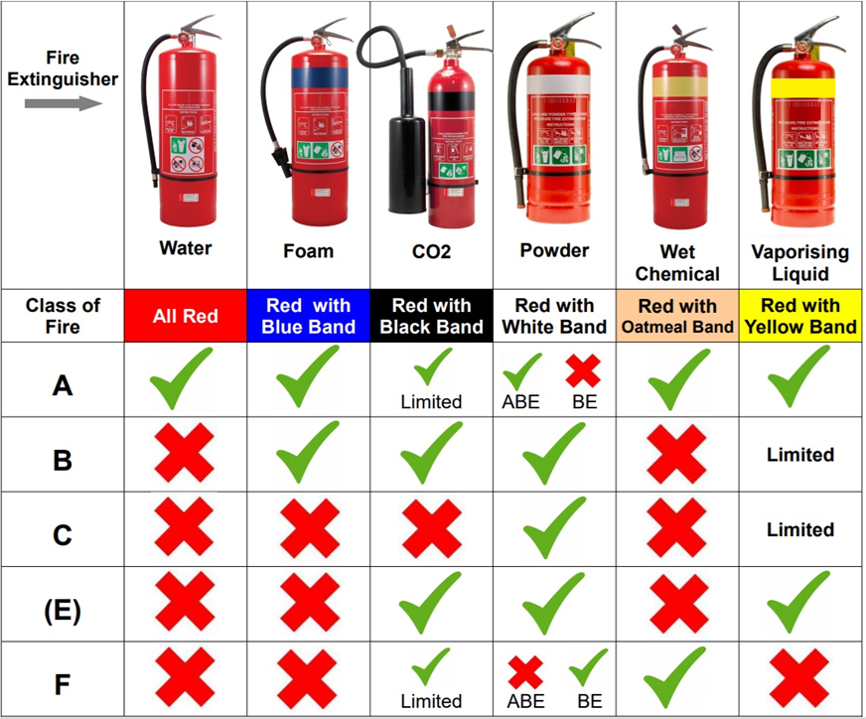

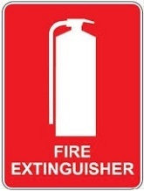

AFTER USE:
Lay the Fire Extinguisher on the ground on its side next to where it usually hangs. This is so people know it has been used. | Notify the office so it can be refilled.

Note: 1. Stand back at least 2 metres from the fire to avoid blow back.
2. Keep low and out of the smoke.
3. Keep the exit to your rear so you can exit if required.
4. Use the correct fire extinguisher for the type of fire.
5. Give the extinguisher a quick squirt to make sure it works, then take to fire.

Emergency response procedures

FIRE BLANKET INSTRUCTIONS
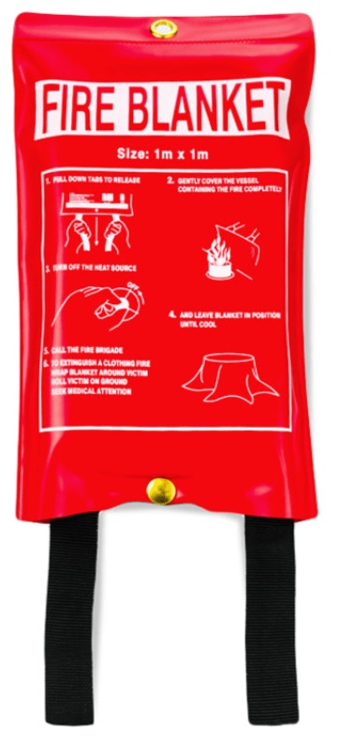
Location Sign
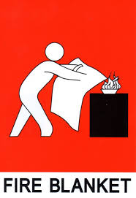

- Pull the Tabs
- Holding the tabs, open fire blanket, protecting your hands with the blanket
- Using the fire blanket as a shield approach the fire
- Place the fire blanket over the fire
For a person/clothing fire, wrap the blanket around the victim to smother the flames

Fire Blankets are for small fires only

Recommended size for commercial use is: 1.2m x 1.8m

Note: 1. Leave the fire blanket on the fire, do not remove as the fire may reignite
2. For a cooking fire, turn off the gas/electricity to allow cooling
3. For machinery, turn off the machine including any electricity or gas supply
4. Call the fire brigade to inspect the scene to ensure there are no fires in equipment, machinery, ceiling spaces, ducts and extraction fans etc
5. You can use a fire blanket to shield yourself from flames to escape as a last resort

Emergency response procedures

FIRE HOSE REEL INSTRUCTIONS
T.T.T.T.

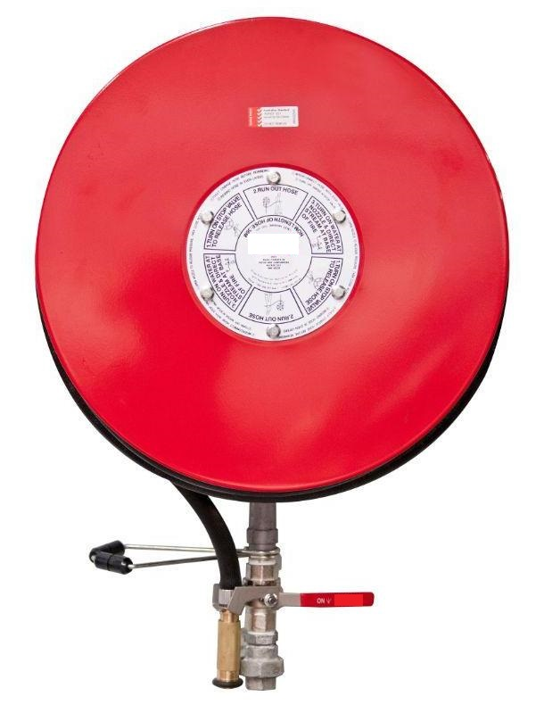

- TURN ON
Turn on the water supply valve
This will release the nozzle and provide water to the hose.

- TEST
Take out 2m of hose and turn on the nozzle to test the water pressure and throw distance. This confirms it is working and tells you how much pressure/throw you are working with.

- TAKE TO THE FIRE
Take the hose to the fire.
If there is more than one person, it is helpful to have one person at the drum to let out hose in a controlled manner to avoid jamming and over-running etc.

- TURN ON NOZZLE AND ATTACK THE FIRE
Turn on the nozzle and Attack the Fire.
Stay low and out of the smoke.
Keep an escape path clear so you can escape.
Use various patterns depending on the fire size and type.
If disoriented by smoke, you can follow the hose back to safety.

Note: 1. Do not pass the fire to get to fire equipment
2. If in doubt, get out

Emergency response procedures

MEDICAL EMERGENCY
D.R.S.A.B.C.D.

D - DANGER
Ensure the area is safe for yourself, others and the patient.

R - RESPONSE
Check for a Response
- Ask Name, Squeeze Shoulders & Ask patient to squeeze your fingers etc.

If there is a response, keep comfortable, seek aid, monitor response.
If there is No Response DO THIS
S – SEND FOR HELP
Dial 000 and state “ambulance” required
(or ask another person to make the call and to confirm to you that this has been done)

A - AIRWAY
Open the mouth and loo inside to check airway is clear
If a foreign object is present: Place patient on side & clear airway with fingers.

If there is Normal breathing: Place in recovery position & Monitor breathing.
If there is No Breathing/or no normal breathing DO THIS
B - BREATHING
Check for breathing – look, listen, feel.
If there is Normal breathing: Place in recovery position & Monitor breathing.
If breathing is not normal or if breathing is absent DO THIS
C - CPR
Start CPR – 30 Chest Compressions and give 2 Breaths

Continue CPR until the patient recovers or until emergency services tell you to stop

D - DEFIBRILLATION
Attach a Defibrillator as soon as possible & follow the voice instructions

Note: 1. Always use gloves and a resuscitation mask.
2. You can use a bystander to take over compressions if you are unable to continue.
3. Use Oxygen and an Air/Bag/Valve if it is available and you are trained in its use.
4. If you are unable or unwilling to give breaths, you may give only compressions.
5. Any attempt is better than no attempt at all.
6. Never leave the patient alone.
7. Do not move the patient unless exposed to a life-threatening situation.
8. Provide support and appropriate assistance until emergency help arrives

Drug Overdose:
Narcan type products are becoming increasingly more available for first aid use. Consider keeping this in your kit due to local socio-economic conditions and the increased chances of drug overdose in your area.

First Aid Kit is located at the Entrance Door

Emergency response procedures

COVID19/Infectious Disease Response
Sourced from: https://www.safeworkaustralia.gov.au/safety-topic/hazards/covid-19
Fact
COVID-19 is a highly contagious disease caused by the coronavirus SARS-CoV-2. It spreads through respiratory droplets or small airborne particles when an infected person coughs, sneezes, or talks, and is in close contact with others.
Purpose
To ensure the safety of staff, visitors, and volunteers by promptly managing COVID-19 cases and reducing transmission risks.
1. Recognising Symptoms
Be alert for symptoms such as fever, cough, sore throat, shortness of breath, loss of taste or smell, fatigue, muscle aches, or nausea.
Individuals exhibiting symptoms must not enter or must isolate immediately.
2. Immediate Actions if COVID-19 is Suspected or Confirmed
- Isolate: The affected person should immediately leave the premises and go home or to a healthcare facility.
- Notify: Inform the designated COVID-19 Coordinator or senior staff or First Aid Officer.
- Clean & Disinfect: Areas used by the affected person must be thoroughly cleaned and disinfected following public health guidelines.
- Contact Tracing: Identify and notify close contacts within the workplace while respecting privacy laws.
- Support & Follow-up: Encourage the affected individual to seek medical advice and follow current health directives.
3. Preventive Measures
- Hygiene: Promote handwashing with soap and water; provide hand sanitiser stations.
- Physical Distancing: Maintain at least 1.5 metres between individuals; restrict gathering sizes.
- Ventilation: Increase airflow in indoor spaces.
- Cleaning: Regularly clean high-touch surfaces and shared equipment.
- Signage: Display health and safety information prominently.
- Health Advice: Encourage self-informing up-to-date information and stay home if unwell.
4. Returning to the Workplace
- Workers who have tested positive must follow public health advice before returning.
- No mandatory isolation is required upon exposure; however, workers should monitor symptoms and notify management if they feel unwell.
- Consult with health authorities for guidance on work adjustments if needed.
5. Responsibilities
- Staff & Volunteers: Follow this procedure, practice good hygiene, and report symptoms promptly.
- Management: Ensure the workplace remains safe, provide training, and maintain cleaning protocols.
- Visitors: Follow signage and instructions; do not attend if feeling unwell.
6. Confidentiality & Privacy
Handle all health information sensitively, sharing only the minimum necessary details to manage risks.

Contact for COVID-19 Concerns
COVID-19 information lines | COVID-19 information lines | 1800 020 080
NSW Department of Health (Public Health Unit) | For Communicable Disease Reporting | 1300 066 055
Chief Warden | Insert Here | Insert Here
First aid officer | Insert Here | Insert Here

Emergency response procedures

BOMB THREAT
If you receive a bomb threat, do not use a mobile phone or set off the fire alarm
– it may trigger an explosion.

Remain calm | - Treat the call as genuine.  - Attempt to prolong conversation and DO NOT hang up.  - Try to attract the attention of a second person to call 000
Be attentive | - Note distinguishing background noises, music, traffic etc.  - Note voice characteristics.  - Does caller indicate knowledge of the building or business?
Record | - Enter the details immediately on the Bomb Threat Checklist form on the next page.
Notify | - Dial 000 and state that a “BOMB THREAT” has been made.  - Your Warden.
Prepare | - To assist in the search if requested.  - To evacuate if necessary.  - To follow instructions of wardens, security, police and other emergency service personnel.
If object found | - Do not touch it. Report that you have found it. Open doors and windows where possible and evacuate area, to reduce the impact of an explosion.

Emergency response procedures

BOMB THREAT CHECKLIST
REMEMBER TO KEEP CALM AND DO NOT HANG UP AFTER THE CALL

Time of Call: |  |  | Date: of Call:
Exact wording of threat:

QUESTIONS TO ASK
When is the bomb going to explode? |  |  | Where did you put the bomb?
When did you put it there? |  |  | What kind of bomb is it?
What will make the bomb explode? |  |  | Why did you place the bomb?
What is your name?
CALLERS VOICE
Accent: |  | □ Australian | □ Middle Eastern |  | □ Asian
□ Pacific Islander |  | □ European | □ American |  | □ English
Speech: |  | □ Fast □ Slow | Voice: |  | □ Loud □ Soft
Gender: |  | □ Male □ Female | Impediment: |  | □ Lisp □ Stutter
Manner: |  | □ Calm □ Emotional | Diction: |  | □ Clear □ Muffled
Other:
Did you recognise the voice? |  | □ Yes □ No | Was the caller familiar with the building/area /business/staff? |  | □ Yes □ No
THREAT LANGUAGE
Well-spoken |  | □ Yes □ No | Incoherent |  | □ Yes □ No
Taped |  | □ Yes □ No | Abusive |  | □ Yes □ No
Message read by caller |  | □ Yes □ No | Other
BACKGROUND NOISES
□ Voices □ Street noises □ Aircraft
□ House noises □ Machinery □ Music
□ Other__________________________________________________________________

RECIPIENT OF PHONE CALL (Your Details)
Name
Email
Mobile
Section/Area
Address
Signature

Note: Suspicious Package

This business is unlikely to receive suspicious packages. However, if a package is received, the Bomb Threat Procedures are to be followed and 000 is to be called immediately.

Emergency response procedures

POWER OUTAGE
REMEMBER TO KEEP CALM AND ASSIST OTHERS IF NECESARRY

During power outage
1. Report the outage, call: (insert here)
please note, during a power outage digital handsets may not work.
Please use a mobile phone instead.

2. If evacuation is necessary, move cautiously. Emergency lighting will assist with egress. Illuminated exit signs will indicate exits.

3. Remain with any immobile individuals who become stranded as a result of the outage.
If emergency assistance is required dial 000 and provide details.

4. In the workshop, specific protocol and procedures will operate during a power outage. Ensure you are aware of these requirements.

Note:
Treat all electrical equipment as live, as power may be restored at any time without notice.
Outage times are difficult to predict depending on the cause. This may take some time to identify.
Await further instructions from your Wardens.

Emergency response procedures

GAS LEAK or CHEMICAL SPILL
CALL 000 IMMEDIATELY
Evacuate Immediately
If it is a gas leak or chemical spill, DO NOT activate PA system, use mobile phones, hand-held radios or electronic equipment inside the area where the gas leak is.

If a gas leak or chemical spill is affecting people in your area, immediately:

1. REMOVE
- Remove anyone in immediate danger only if it is safe to do so.
- DO NOT allow other people in the area.
- If anyone is exposed to a substance, set up an isolation area.
- If available and only if it is safe to do so, put on personal protective equipment, observe and support the person until Emergency Services arrive.
- DO NOT put yourself at risk.

2. ISOLATE
- Isolate the hazardous material by clearing the area,
- Close the doors.
- If safe to do so turn off isolation switches, ventilation and machinery.
- DO NOT touch suspect material.

3. NOTIFY
- If it is a “gas” or “chemical”, shout a warning,
- Pass the alarm by word of mouth.
- If able to ring from a safe area away from the leak or spill, DIAL 000 from a landline, state there is a hazardous material incident and give exact location and type of material involved.

4. CONTAIN (if safe to do so for minor non-emergency/non-life-threatening chemicals)
- Do not risk contact with material or allow it to spread to drains.
- Do not smell, touch or taste it.
- Close doors between you and the hazardous material.

Note:
Evacuate and notify authorities if in doubt.

Only attempt to contain chemical spills if you are trained, equipped and it is not life threatening.

All Gas Leaks must be reported to 000 immediately will a full evacuation.

Flammable Liquids Spills:

Treat as for a chemical spill, except prepare for fire.

If unsure of threat/severity, contact 000 for assistance and evacuate the premises.

Emergency response procedures

PERSONAL THREAT
CALL 000 IMMEDIATELY
Threats to self or others may include harassment, assault, suicide, robbery or armed hold-ups.

Remain calm
- Do not panic or shout, avoid eye contact.
- Do not make sudden movements.

Do not take risks
- Hand over whatever is requested.
- Do not do anything which may antagonise the offender.
- Alert others around you if safe to do so.
- Contain yourself in a secure area, by locking your office door, closing blinds and staying out of sight.

Do only what you are told
- Do not volunteer any other information.

Personal Threat Report
(observe offender’s characteristics)
- Sex, height, voice, clothing, tattoos, jewellery, items touched, etc.
- Also note type of vehicle used for escape, registration number if
possible and last known direction.

Telephone
- Dial 000 and request POLICE
- Stay on the line and keep the line of communication open.
- Give your name, building address, work location and request
urgent attendance.
- Most importantly – Remain CALM.

Record
- Immediately fill out the Personal Threat Report (on next page) with the offender’s description, what they may have taken (models and serial numbers), descriptions of any items they may have or any other relevant details.

Emergency response procedures

PERSONAL THREAT CHECKLIST
To be completed immediately after incident. Try to be as descriptive as possible.
Use a separate form for each offending person’s description.

Your Contact Details
Name
Email
Mobile
Section/Area
Address
Signature
Time of Threat: |  | Date of Threat:
Details of threat:

OFFENDER’S DETAILS/DESCRIPTION
Any names or nicknames used
Approximate age |  | Male or Female
Height |  | Weight
Ethnic origin |  | Other Features
Facial | □ Moustache □ Beard | Spectacles | Size:  Colour:
Build | □ Thin □ Stout □ Overweight  □ Medium □ Small □ Obese
Posture | □ Erect □ Stooped □ Slouchy
Walk | □ Quick □ Springy □ Slow  □ Limp □ Pigeon toed □ Medium
Hands | □ Callused □ Soft □ Hairy  □ Nails missing □ Deformed fingers
Gloves | Type: Colour:
Voice | □ Thick □ Accent □ Clear  □ Loud □ Soft □ Lisp □ Stutter
Eyes | Eye colour:  □ Intense stare □ Squint
Complexion | □ Fair □ Dark □ Pale □ Fresh  □ Ruddy □ Suntanned □ Pimply □ Normal
Hair | □ Straight □ Wavy □ Bald □ Curly  □ Thick □ Long □ Crew cut □ Short
Other Comments:

Emergency response procedures

ACTIVE SHOOTER/Violent Offender
If you can safely evacuate: Run

1 If there is an escape path, attempt to evacuate

2 Escape, try to take people with you (but do not let unwilling people slow you down)

3 Leave your belongings behind

4 Help others escape/alert others along the way if possible (but do not let unwilling people slow
you down)

5 Prevent others from entering the area

6 Call 000 when you are safe

7 DO NOT RE-ENTER THE BUILDING UNDER ANY CIRCUMSTANCES

Remember: The more distance and barriers between you and the threat, the better.

If you are trapped: Hide

1 Move to a separate room

2 Lock and/or barricade the door

3 Turn off lights

4 Silence your phone, take landlines off the hook to prevent ringing

5 Hide behind heavy objects

6 Remain silent, breathe slowly and quietly, remain as calm as possible

7 Arm yourself with something you can use as a weapon and be prepared to defend yourself as a
last resort

Your hiding place should:
- Be out of view of the attacker/s
- Be resistant to forced entry
- Provide protection from gunfire if possible
If you cannot Run or Hide: Fight

You have the legal right to defend yourself. Incapacitate the attacker/s as best you can

1 If you cannot Run or Hide, be prepared to defend yourself.

2 Arm yourself with anything that can be used as a weapon.

Possible weapons found in office environments could include:
- Fire Extinguishers
- Chairs
- Kitchen Knives
- Boiling Water
- Hard Heavy Objects
- Broom/Mop,

3 Attack as a team. Overwhelm the attacker/s.

4 Be as aggressive as possible and totally commit to your actions.

5 Shout/Scream as Aggressively and as Loud as possible as you attack.

6 If you are injured, do not stop fighting until the threat is stopped.

7. Do not fight fairly. THIS IS ABOUT YOUR SURVIVAL and DEFENDING INNOCENT PEOPLE.
Do what-ever you must do to stop the threat.

Emergency response procedures

NATURAL DISASTER
Remain calm, remove anyone from immediate danger if safe to do so.
- FLOODING
- If the building is in danger of being flooded, evacuate all staff and visitors to a safe area unaffected by flooding. Otherwise, do not evacuate unless instructed by your Warden.
- Switch off any electrical equipment and gas that could be affected by water if safe to do so.
- Move any chemicals, documents, equipment and valuables to a safe area if time permits.

- STORMS
- Move all people away from windows.
- Close all curtains, drapes and blinds.
- Shelter in strongest part of building (e.g. bathrooms/central corridors).
- Stay clear of large areas with glass atriums or glass roofs.
- Stay inside.

- EARTHQUAKES
If inside:
- Stay inside.
- Do not use lifts or stairs.
- Take shelter in doorways, under desks, or down beside an internal wall.
- Stay clear of large areas with glass atriums or glass roofs.
- Keep away from windows or objects that could fall on you.

If outside:
- Stay outside.
- Take shelter clear of buildings, trees, power lines or other potential hazards.

WHEN THE EARTHQUAKE STOPS:
- Check for signs of fire, hazardous material spill or major structural damage.
- Account for all staff and visitors if possible. Treat any minor injuries.
- Evacuate immediately.
- Await further instructions from Emergency Services.
- Close any doors in your area.

EXPECT AFTERSHOCKS

- BUSHFIRES
Refer to “BUSH FIRE” procedures

FOR ANY LIFE THREATENING EMERGENCIES
CALL 000 IMMEDIATELY

Emergency response procedures

EVACUATION
Evacuation is the rapid removal of people from immediate or threatened danger
in a safe and orderly manner.
- Remain calm
Do not panic, calm those who appear agitated around you.

- Alert
Notify your Warden.
Follow instructions from your Warden.
Notify the Office of the Evacuation.

- Assembly
Inform staff and visitors which assembly area to use.
Go to the Assembly Area located at the front of the premises.

- Evacuate
Due to the size of the premises, all evacuations will be total evacuations

If relevant, evacuate in the following order:
- People in immediate danger first, then in the following order:
- Mobile person
- Semi mobile person; and
- Immobile person then lastly unwilling/uncooperative person.

Use suitable carry/drag methods if required.

- Check
- Check all rooms, especially change rooms, toilets, storage areas.
- Note anyone who does not wish to evacuate, record their location and name and report this to the Chief Warden

- Head Count
- Conduct a head count.
- If anyone is missing, report this immediately to the chief warden.

- Report
- Report to your chief warden if your floor has evacuated safely.
- Notify emergency services of any persons unaccounted for.

Note:
It is your responsibility to know where the Assembly Area is. It is also your responsibility to learn and know your safe emergency evacuation exit out of your normal work area. Every emergency can bring changes to the way you leave the building.

Emergency Control Equipment

Location |  |  |  |  |  | Church/Worship Area
Type of Equipment: |  |  |  |  |  | Maintenance Frequency |  |  | Responsible Person
3.5KG CO2 Fire Extinguisher (Main Door) |  |  |  |  |  | 6-monthly
9L Water Extinguisher (Stage) |  |  |  |  |  | 6-monthly
3.5KG CO2 Fire Extinguisher (Rear Door) |  |  |  |  |  | 6-monthly
Emergency & Exit Lighting |  |  |  |  |  | 6-monthly
Smoke Alarms |  |  |  |  |  | 6-monthly
First Aid Kit (Main Door) |  |  |  |  |  | Annual Check
Defibrillator (Main Door) |  |  |  |  |  | Annual Check
Company Self-Checks (Monthly)
JAN | FEB | MAR | APR | MAY | JUN |  | JUL | AUG |  | SEP | OCT | NOV | DEC
Note Issues Below

Location |  |  |  |  |  | Kitchen and adjoining Hall
Type of Equipment: |  |  |  |  |  | Maintenance Frequency |  |  | Responsible Person
Fire Blanket (Kitchen) |  |  |  |  |  | 6-monthly
Fire Blanket (Kitchen) |  |  |  |  |  | 6-monthly
3.5KG CO2 Extinguisher (Adjacent Kitchen) |  |  |  |  |  | 6-monthly
9L Water Extinguisher (Rear Door) |  |  |  |  |  | 6-monthly
Emergency & Exit Lighting |  |  |  |  |  | 6-monthly
Smoke Alarms |  |  |  |  |  | 6-monthly
First Aid Kit (Kitchen) |  |  |  |  |  | Annual Check
Company Self-Checks (Monthly)
JAN | FEB | MAR | APR | MAY | JUN |  | JUL | AUG |  | SEP | OCT | NOV | DEC
Note Issues Below

Add more sections as required

List of possible Essential Fire Safety Measures:
Access panels, doors and hoppers to fire-resisting shafts | Fire windows
Automatic fail-safe devices | Lightweight construction
Automatic Fire Detection and alarm systems | Mechanical air handling systems
Automatic Fire Suppression systems | Perimeter vehicle access for emergency vehicles
Emergency Lifts | Portable fire Extinguishers & Fire Blankets
Emergency Lights | Safety curtains in Proscenium openings
Emergency Planning | Smoke alarms and heat alarms
Emergency Warning and intercommunication systems | Smoke and heat vents
Exit signs | Smoke dampers
Fire alarm monitoring | Smoke detectors and heat detectors
Fire control centres and rooms | Smoke doors
Fire dampers | Solid core doors
Fire doors | Standby power systems
Fire hose reel systems | Wall-wetting sprinklers and Drencher systems
Fire hydrant systems | Warning and operational signs
Fire seal protection openings in fire-resisting components of the building | Paths of Travel
Fire shutters

Testing the Emergency Plan

An annual evacuation drill shall be performed (additional for any change to workplace/staff)
Frequency | Annual (and as required)
Type of Test | Practice Evacuation
Participants | All Staff
Details
Date of Test |  | Time of Test
Location of Assembly Area |  | Time all accounted for
Note Issues Below
Names of all Participants

An annual Review of this Emergency Plan shall be conducted by management in conjunction with the EPC and ECO (and as required should any construction or staff changes occur)
Frequency | Annual (and as required)
Type of Test | Assessment for relevance and suitability
Participants | Management, ECO and EPC
Details
Date of Review
Note Issues and Outcomes Below
Names of all Participants

Monthly company self-testing of the Smoke Alarms and PA system shall be conducted by the Chief Warden or Office Manager.
Frequency |  |  | Monthly
Type of Test |  |  | Canned Smoke to Smoke Alarms to test for functionality.  Activation of PA system to test for functionality.  All areas of the business will be assessed to confirm audible warnings are clear and correct.  Emergency and Exit Light testing shall be via activation of the ”Emergency Test Switch” located at the Main Switchboard.
Name of Tester
Details
Date of Review
Name of Tester
Company Self-Checks (Monthly)
JAN | FEB | MAR |  | APR | MAY | JUN | JUL | AUG | SEP | OCT | NOV | DEC
Note Issues Below

Training

Emergency training will be provided annually for:
- New employees within the first month of employment.
- Refresher training for existing employees every year.
- Initial Training of ECO/Wardens will be conducted by a qualified external trainer.

ECO/Wardens shall receive professionally provided initial training in accordance with Australian Standards.
Frequency | Once Off/Initial (and as required/3-yearly)
Type of Training | External Provider in accordance with Australian Standards
Participants | All ECO staff
Details
Name |  | Date of Training & Provider | Renewal Date (3-years)

ECO/Wardens shall receive annual in-house training in the emergency plan and evacuation procedures in accordance with Australian Standards.
Frequency | Annual (in-house training)
Type of Training | ECO and EPC to review Plan: 4 hours  All Staff to participate in Evacuation Exercise
Participant Details
Name |  | Date of Training

All Staff. ECO/Wardens shall provide staff with instructions on the use of response equipment and evacuation procedures.
Frequency | Quarterly (in-house training)
Type of Training | In house provided by ECO to other staff in use of fire equipment and evacuation procedures.
Participant Details
Name |  | Dates of Training

After an Emergency

- Notify emergency services of the situation (if required) including any injuries, and property damage.

- Perform a debriefing session with all staff to learn from the incident.

- Document the incident thoroughly for records and compliance reporting.

- Develop a business continuity plan to maintain operations post-incident.

- Notify any repair contractors and insurance company of the incident if any damage has occurred.

- Return to normal business operations when the “all clear” is given by the Chief Warden or Emergency Services.

Incident Log
Date of Incident
Time of Incident
Type of Incident
Location of Incident
Details
Names of those involved |  | Role in Incident
Notes:

Reviewing, reporting and record-keeping

This Emergency Plan will be reviewed annually in consultation with staff and after any emergency incidents. (and as required) in accordance with section:

“Testing the Emergency Plan”

Records shall be kept in both electronic and hard copy (located in the office).
- Records will be maintained for each exercise, training session, and incident response.
- Compliance checks will be documented and filed appropriately.

Copies of the Emergency Plan shall be displayed on the notice boards located in the office and in the workshop.

All staff shall be consulted when the Emergency Plan is reviewed.

END OF DOCUMENT

Created by

Timothy Wainwright
Director of Fire Safety & Training
Fire Support NSW

M: 0413 229 347
E: info@firesupport.com.au
W: www.firesupport.com.au

