Our Policy
Presbyterian Church of Australia in the State of New South Wages (PCNSW) is committed to ensuring safeguards are in place to identify and prevent elder abuse and protect staff who report actual or suspected elder abuse. Thus, PCNSW employees are obligated to the prevention of elder abuse, identifying actual or suspected elder abuse and take appropriate actions to manage elder abuse.

Declaration
PCNSW values the dignity of worth of all people created in God’s image and seeks to treatment all with care and compassion. PCNSW is committed to the provision of safe, caring and inclusive environments and communities for the older person. As part of that, we are committed to preventing abuse of older people and to respond promptly where it does occur.

Purpose
Promote an environment that supports the safety of the residents who live in our retirement villages.
Promote an environment that provides for the residents, their families and staff to freely raise any concerns they may have about the abuse or possible abuse of a resident and to have those concerns dealt with appropriately.

Scope
PCNSW maintains a strong commitment to our duty of care to its residents and staff. Staff members who work for PCA NSW are required to support and promote our duty of care principles and act accordingly in our workplace and our communities. It is considered a breach of duty of care if:
- A staff member is a witness of abuse, is informed of abuse or is suspicious of abuse to a resident and does not act in accordance with the organisation’s policy and reporting requirements, or
- A staff member provides advice to a resident that is outside their scope or competence or beyond what is required and expected in their position.

Related Legislation
Retirement Villages Act 1999.
Retirement Villages Regulation 2017.

What is elder abuse?
The World Health Organisation’s (WHO) definition of the abuse of older people:
“A single or repeated act, or lack of appropriate action, occurring within any relationship where there is an expectation of trust which causes harm or distress to an older person”.
Elder abuse can take various forms such as physical, psychological or emotional, sexual and financial abuse. It can also be the result of intentional or unintentional neglect. In this context, abuse is generally perpetrated by a relative of the older person where the trust relationship involves dependency and proximity to the older person such as an adult child or spouse. Supporting and educating the older person, no matter what their choices are in relation to their situation is paramount. Providing information about available support and options can support the older person in their decision-making and in making referrals.

What elder abuse is not
Age discrimination, or an estranged relationship with a relative are not examples of elder abuse.
Elder abuse is also not a crime committed by a stranger. It does not involve self-neglect or self-mistreatment – rather, the abuse happens at the hands of a trusted person.

What are the types of elder abuse?
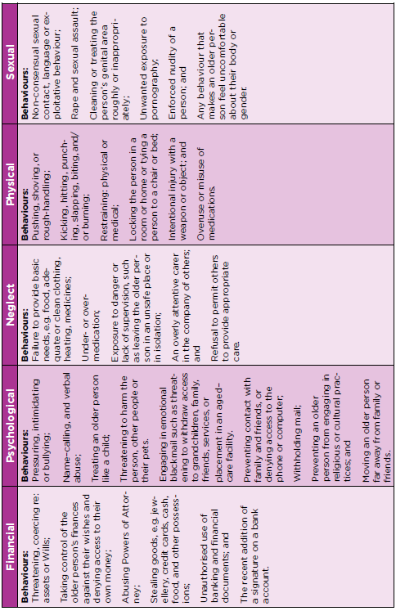
Source: NSW elder abuse helpline & resource unit, NSW Elder Abuse Toolkit, 2016

What are the signs of elder abuse?
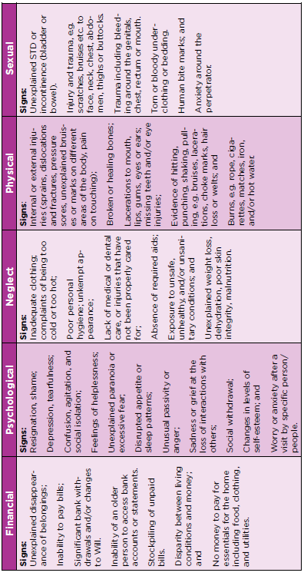
Source: NSW elder abuse helpline & resource unit, NSW Elder Abuse Toolkit, 2016

A case scenario in a retirement village
A husband has no understanding about his wife who lives in the village and who is living with dementia. He has been advised many times both verbally and in writing.
The husband yells at the wife to stop being so stupid (emotional/psychological abuse) and expects the wife to provide daily living requirements such as meals, laundry, cleaning, shopping etc. – the lifelong expectation of the husband. The husband becomes increasingly embarrassed about his wife’s “behaviour” and isolates her, restricting enjoyment of friends and family (psychological abuse). The husband starts smacking her to force her to walk and behave in a particular way (physical abuse).

What can the management and staff do in an emergency?
- Call 000 without delay, and depending on the circumstances:
- Contact other emergency services and arrange medical treatment.
- Arrange emergency accommodation.
- Determine capacity of an older person and make an urgent Guardianship application.
- Other support sensitive to culture, sexual identity and religious beliefs.

- What if I am unsure about whether it is an emergency?
- An emergency is when there is an immediate threat or risk of physical harm or serious
damage to property. Workers should review their own policies about emergency
situations
- The threat or risk may be suspected or actual. If you are unsure, it is safest to
treat it as an emergency.

- What can the police do?
The NSW Police respond to emergencies and have powers under NSW Crimes acts. Some forms of elder abuse are crimes.
- Conduct a welfare check
- Investigate a report that is made which may lead to criminal charges
- Under some circumstances, gain access and entry to premises
- Apply on the person’s behalf for an Apprehended Domestic or Personal Violence
- Order which can include an Exclusion Order
- Ring an ambulance or mental health team and make referrals

- What if the older person does not want help?
Older people should be involved in making decisions about their life as much as possible, including in an emergency. However, if a worker decides a person is in imminent danger, they must act, even if this goes against the person’s wishes. This relates to ‘duty of care’ to avoid further harm.
Source: NSW elder abuse helpline & resource unit, NSW Elder Abuse Toolkit, 2016

Steps to identify and respond to elder abuse
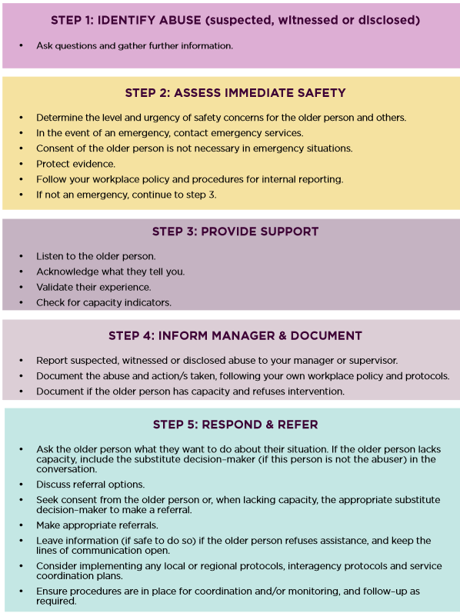
Source: NSW elder abuse helpline & resource unit, NSW Elder Abuse Toolkit, 2016

Effective questions
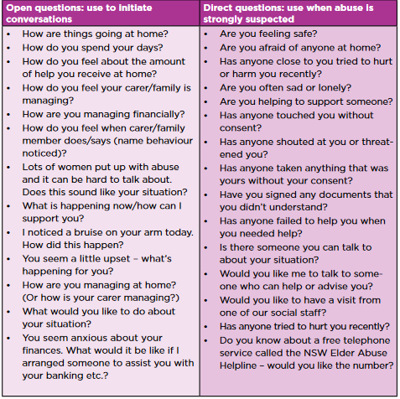
Source: NSW elder abuse helpline & resource unit, NSW Elder Abuse Toolkit, 2016

Emergency Contacts
Name | Number | Website Address
Police/Ambulance/Fire | 000 | -
Police/Ambulance/Fire – call from mobile | 112 | -
Ageing & Disability Abuse Helpline | 1800 628 221 | http://www.elderabusehelpline.com.au/
NSW Rape Crisis Centre | 1800 424 017 | http://www.nswrapecrisis.com.au/
NSW Domestic Violence Line | 1800 656 463 | -
Seniors Right Service | 1800 424 079 | https://seniorsrightsservice.org.au/
Social Work Services at Ryde Hospital | 02 9858 7888 | -
NSW Fair Trading | 13 32 30 | https://www.nsw.gov.au/departments-and-agencies/fair-trading
Legal Aid | 1300 888 529 | https://www.legalaid.nsw.gov.au/
NSW Trustee & Guardian | 1300 109 290 | https://www.nsw.gov.au/departments-and-agencies/trustee-guardian
Ageing and Disability Commission | 1800 628 221 | https://ageingdisabilitycommission.nsw.gov.au/

NSW elder abuse helpline & resource unit, NSW Elder Abuse Toolkit, 2016
Relationships Australia, website accessed 9/07/2019

