
PSNSW GRIEVANCE RESOLUTION PROCEDURE

Introduction
The Bible commands that God's people be completely humble, devoted to one another in love, and valuing others above themselves, so they may be united through the bond of peace (Ephesians 4:2-3; Romans 12:10; Philippians 2:3).
As God's chosen people, holy and dearly loved, Paul encouraged fellow believers to clothe themselves with compassion, kindness, humility, gentleness and patience; to bear with each other and to forgive one another if they have a grievance against someone; to forgive as the Lord forgave them; and over all these virtues to put on love, which binds them all together in perfect unity (Colossians 3:12-14).
The church recognises that the first point of call in a grievance is informal resolution, namely personal peacemaking responses including overlooking an offence (Proverbs 19:11), reconciliation (Galatians 6:1-3, Matthew 18:15) and negotiation (Philippians 2:3-4). In some instances, assisted peacemaking responses involve others in the church including mediation (Matthew 18:16) and adjudication (1 Corinthians 6:1-8). This is not relevant to serious complaints.
In Christ, the Presbyterian Church of Australia in NSW (the Church) is committed to developing a culture where all employees, contractors, volunteers, communicants, adherents and visitors (People) within the Congregation are able to raise issues, concerns and complaints and have them addressed as soon as practicable, using safe, fair and equitable processes.
This Procedure outlines the process for voicing, managing and resolving complaints within the Congregation.

Scope
This Procedure applies to any People who wish to express dissatisfaction, concerns or allegations regarding decisions, behaviours, conduct or conditions in the Church, impacting themselves or others.
Complaints addressed by this Procedure include matters concerning:
- Conflict between congregation members.
- Conflict with a Congregation Leader.
- Inappropriate behaviour by a Congregation Leader.
- Ministry decisions, processes or practices that affect People in the Congregation, including unsatisfactory working conditions (such as workload or lack of resources) and safety.
This Procedure does not apply to:
- Complaints relating to behaviour as outlined in the Breaking the Silence Code of Conduct, including child abuse, sexual misconduct, or any other Notifiable Circumstance. Complaints of this nature must immediately be reported to the Conduct Protocol Unit.
- Reportable offences as listed in the Whistleblower Policy. Complaints of this nature should be reported in accordance with the procedure set out in the Whistleblower Policy.
- Conduct that is the subject of the Code of Discipline (The Code Parts I, II and III), including doctrinal matters.
These documents can be found on the PCNSW website: https://pcnsw.org.au/the-code-and-policies/

Definitions
Complainant means a person who makes a Complaint.
Complaint includes an expression of dissatisfaction about a matter involving miscommunication or interpersonal conflict, perceived unfair treatment, minor breaches of policies or procedures, disagreements, concerns about the physical environment, terms and conditions of employment, or organisational change, practices and behaviours.
Congregation Leader means a minister or other gospel worker appointed by the Presbytery, an elder or deacon or other ministry leader serving in the Congregation (paid or unpaid), including members of the Committee of Management.
Respondent means the person against whom a Complainant brings a Complaint.
Serious Complaint includes a concern or allegation about a matter involving a breach of legalities, including bullying or harassment, discrimination, sexual misconduct, fraud or corruption, risks to psychosocial health and safety and serious breaches of legal or ethical obligations.
Work means any tasks, responsibilities or activities undertaken by People by, or for, the Congregation.

Resolution Processes
In keeping with the Bible's instruction that God's people are to be completely humble, bearing with one another in love, the Church encourages any Complainant to first attempt to resolve the Complaint informally where appropriate.
The Church recognises that some complaints are most appropriately dealt with greater support and formality, such as where the Complaint relates to behaviour that constitutes a Serious Complaint.
Where the Respondent believes that the subject of the Complaint is frivolous or vexatious, the matter should be assessed by the Session before the complaint progresses within the Resolution Guidelines (i.e. Diagram 1).
In addition, if a Complaint is made and the Respondent is a member of Session, to address any conflict of interest, a Committee of Session should be appointed and exclude the Respondent. If the conflict of interest cannot be properly addressed in this manner, the Complaint should be escalated to the Presbytery.
Otherwise, the processes set out in Diagram 1 should be adopted in addressing, hearing and resolving Complaints.

Diagram 1
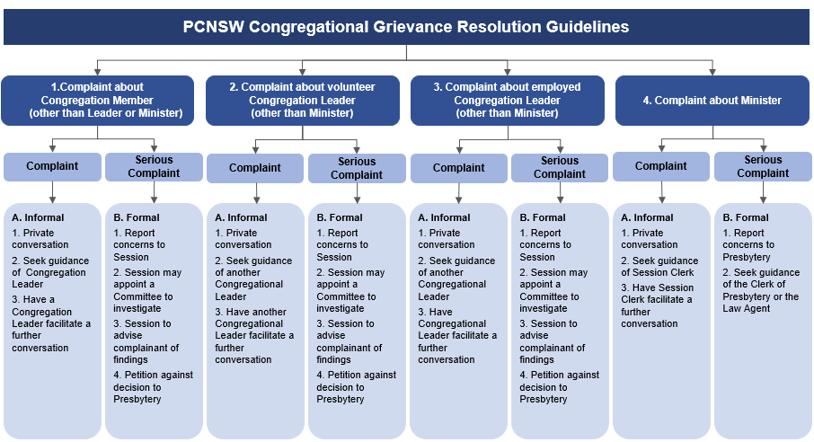

1. Complaint about a Congregation Member (other than Leader or Minister)
1A. Informal
A Complainant should ensure their Complaint is voiced as soon as reasonably practicable after the alleged conduct has occurred. The Complaint should be outlined in a letter, in a clear and objective manner, and include any actions that they believe would resolve the Complaint.
The Complainant is encouraged to first follow the course of personal peacemaking i.e. private conversation described in Matthew Chapter 18: 15-17: that is, to meet with the person who has caused their Complaint, to gently point out their fault. If it will assist the Complainant, they may ask a support person to be with them during the conversation.
If the Complaint is unable to be resolved in private conversation, the Complainant is encouraged to seek guidance from a Congregation Leader. The Congregation Leader should then facilitate a further conversation between the Complainant and the Respondent, with a view to resolving the matter.
1B. Formal
If the matter is unable to be resolved informally, or if the Complaint is of a kind relating to a Serious Complaint, the Complainant may report their concerns to the Session. The Complainant should outline their Complaint in a letter, clearly and objectively, and include any actions that they believe would resolve the complaint.
In accordance with Chapter 8, Part 3 of the GAA Code of Discipline, Session may appoint a Committee of one or more of its members to investigate the Complaint. Where appropriate, the Complainant may request, or Session may recommend, that at least two female Congregation Leaders be appointed to participate in the investigation of the Complaint.
Once the investigation is concluded, Session, or the Committee appointed by Session, may elect to confer in private with the Complainant and the Respondent together, with a view to resolving the Complaint through Christian mediation. The Complainant may invite a support person to attend Session with them at this stage.
Session, or the Committee, will then formally advise the Complainant of the findings in writing.
If the Complainant is dissatisfied with the finding and wishes to have the finding reviewed, they may petition to the Clerk of the Presbytery.

2. Complaint about a volunteer Congregation Leader (other than Minister)
2A. Informal
The Complainant is encouraged to follow the informal process outlined in Diagram 1.
2B. Formal
If the Complainant considers there are extenuating reasons to escalate their Complaint, or if the complaint is a Serious Complaint, the Complainant should follow the formal process outlined in Diagram 1. The Complainant should outline their Complaint in a letter, and include any actions that they believe would resolve the complaint.

3. Complaint about an employed Congregation Leader (other than Minister)
3A. Informal
The Complainant is encouraged to follow the informal process outlined in Diagram 1.
3B. Formal
If the Complainant considers there are extenuating reasons to escalate their Complaint, or if the Complaint is a Serious Complaint, the Complainant should follow the formal process outlined in Diagram 1. The Complainant should outline their Complaint in a letter, and include any actions that they believe would resolve the complaint.
However, if the Complainant is an employee of the Congregation and the Complaint is about another employee of the Congregation, the Complaint must be addressed under the complaint procedure required by the relevant Industrial Award or Agreement.

4. Complaint about the Minister
4A. Informal
The Complainant is encouraged to follow the informal process outlined in Diagram 1.
4B. Formal
If the Complainant considers there are extenuating reasons to escalate their Complaint, or if the complaint is a Serious Complaint, the Complainant should report their concerns to the Presbytery to be dealt with by the Clerk of the Presbytery or the Law Agent. This report should be made in writing, and include any actions that the Complainant believes would resolve the complaint.

Guiding Principles
During the complaint resolution process, the Church will seek to apply the following guiding principles:
- Promptly respond to complaints.
- Not victimise the Complainant.
- Support all parties to the complaint.
- Maintain neutrality when implementing this Procedure to resolve complaints.
- When requested or required in a Serious Complaint, maintain the confidentiality of the identity of the Complainant.
- Where appropriate, keep records of any findings and resolutions.

Authority

This Procedure is approved for the use of the Church by:

Congregation Name

____________________________________________

Name of Person Signing

____________________________________________

Position of Person Signing

____________________________________________

Date

___________________________________________

