
PSYCHOSOCIAL RISK ASSESSMENT PROCEDURE

Introduction
The Presbyterian Church of Australia in NSW (the Church) is committed to providing a safe place of worship and work. This includes taking all reasonably practicable steps to provide the congregation, employees, contractors, volunteers, communicants, adherents and visitors (People) with a safe and healthy environment. To meet this commitment to its People, the Church has implemented a safety management system (SMS), which includes a Psychosocial Policy, Grievance Resolution Procedure and this Psychosocial Risk Assessment Procedure (Procedure).
This aim of this Procedure is to give effect to our Church's Psychosocial Policy. This Procedure seeks to ensure that psychosocial hazards are identified, assessed and controlled in accordance with WHS legislation and Managing Psychosocial Hazards at Work: Code of Practice.

Scope
This Procedure sets out a risk management process to address any psychosocial hazards that may arise within the Church and its associated external activities, and any exposure of its People to psychosocial risks.

Risk Management Process
The risk management process to address psychosocial hazards and risks is illustrated below in Diagram 1.
Diagram 1
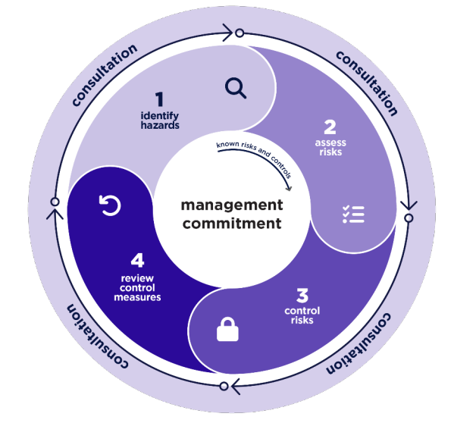

1. Identify Psychosocial Hazards
Our Church will seek to identify all reasonably foreseeable psychosocial hazards that arise from the activities of the Church, in respect to risks to:
- Members of the Congregation.
- Leaders and employees of the Church.
- Visitors and guests.

A "Leader" includes Ministers, Elders and Deacons, Bible Study leaders, Youth Group leaders and Sunday School leaders or other gospel workers appointed by the Presbytery and Elders.
Generally, these psychosocial hazards can be identified through:
- Surveys and workshops.
- Observations of behaviours.
- Incidents, accidents and near misses.
- Complaints and investigations.
The type of psychosocial hazards that might pose a risk to a member of the Congregation, a Leader or employee of the Church is set out below.
Congregational members
In respect to congregational members, psychosocial hazards may arise when there is:
- Conflict or poor relationships & interactions.
- Lack of procedural fairness, including poor consultation.
- Bullying
- Harassment and aggression.
The process for identifying any psychosocial hazards to a Congregational member is outlined in Appendix A: Survey of Wellbeing, located at Appendix A.
Leaders and employees
In respect to Leaders and employees of the Church, psychosocial hazards may arise when there is:
- Conflict or poor relationships & interactions.
- Lack of procedural fairness, including poor consultation.
- Bullying.
- Harassment and aggression.
- Lack of support and clarity.

The process to identify any psychosocial hazards to a Congregational member is outlined in the Survey of Wellbeing, located at Appendix A.

2. Assess Psychosocial Risks
When a psychosocial hazard has been identified as arising from the activities of the Church, either to a Member of the Congregation or to Leaders and employees, the Church, will assess the level of harm this hazard presents through the application of its risk assessment matrix, illustrated below in Diagram 2 - Risk Rating.
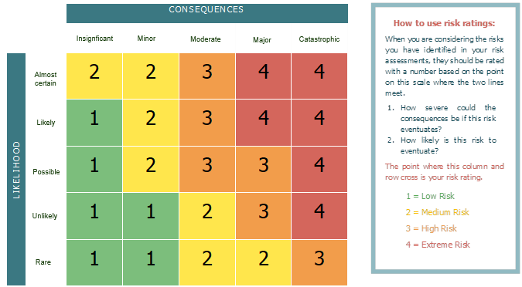
Diagram 2 - Risk Rating

When determining a Risk Rating, consideration should be given to the following:
- The "Likelihood" rating: this is determined by the numerical grade indicated on the Survey of Wellbeing, located at Appendix A. On a collective basis, the data from the survey responses should be graded as follows:
Likelihood
Category | Description
Never | If never is selected, the likelihood risk rating is 1.
Rarely | If rarely is selected, the likelihood risk rating is 2.
Occasionally | If occasionally is selected, the likelihood risk rating is 3.
Frequently | If frequently is selected, the likelihood risk rating is 4.

- The "Consequences" rating. This is a matter of judgment, but should involve consideration of the following examples:
Consequences
Category | Description
Insignificant | Temporary stress or dissatisfaction.
Minor | Occasional fatigue, minor drops in engagement or productivity.
Moderate | Persistent stress, notable decline in engagement or productivity.
Major | Potential for self-harm, extended periods of absence from Church, diagnosable mental health issues.
Catastrophic | Potential for psychiatric hospitalisation or suicide.

This processes of risk assessing any psychosocial hazards is outlined in the Psychosocial Risk Assessment Tool, located at Appendix B.
In summary, Appendix B requires congregational members to complete a survey, typically every two years or as otherwise required (e.g. when a formal complaint has been made about a Leader), which asks questions in respect to:
- Each Member's experience with the Leadership or employees of the Church
- Concerns or suggestions that a Member would like to make known to the Leadership of the Church.
In summary, this tool requires a workshop to be held with Leaders of the Church where:
- Training is provided in respect to:
  - Understanding and responding to psychosocial risk in the Church - see Leadership training on responding to Psychosocial (see training video and materials at https://pcnsw.org.au/work-health-and-safety/ )
  - The requirements of this procedure - see Psychosocial Risk Assessment Procedure.
  - The Church's process for responding to any grievance - see Grievance Procedure.
- Feedback is provided in respect to:
  - Results from Congregational Survey.
  - A self-assessment of their mental health in the context of leadership demands.
The mental health continuum
When conducting the risk assessment, regard should also be had to where individual people may sit on the the mental health contium, illustrated below in Diagram 3.

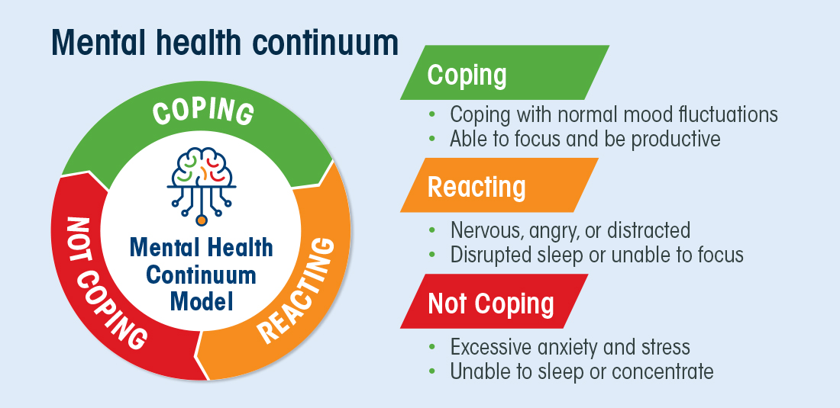
Diagram 3

3. Control Psychosocial Risks
Once identified and assessed, the Church will implement control measures to eliminate, and when not reasonably practicable to eliminate, minimise psychosocial risk.
Controls to be considered include:
- Deliver training on psychosocial risk - see Leadership training on responding to Psychosocial Risks (see training video and materials at https://pcnsw.org.au/work-health-and-safety/)
- Enforce anti-bullying and anti-harassment practices- see Psychosocial Policy.
- Establish safe, confidential communication channels for reporting concerns - see Grievance Procedure.
- Promote active engagement and two-way feedback - See Survey of Wellbeing, located at Appendix A.
- Define and communicate clear roles and expectations.
- Re-designing how work undertaken by the Church is managed, organised, supervised and supported.
- Coach People, in particular leaders, on interpersonal interactions and changing behaviours.
- Foster a culture of work-life balance and healthy boundaries.
- Cultivate a supportive and inclusive culture within the Church and its activities.
- Provide pastoral supervision and emotional support.

4. Review Psychosocial Control Measures
Every two years, or more frequently if required (e.g. a formal complaint is made), the Church may re-conduct the Survey of Wellbeing, located at Appendix A. When appropriate, the Church will compare results of previous Survey's to determine if risks have been eliminated or minimised. In circumstances where there are new risks and pre-existing risks remain, the Church will consider re-conducting the risk assessment and, where deemed necessary, implement additional controls. These additional controls should include those detailed above (or other new controls as are appropriate) and be commensurate to the level of assessed risk (e.g. Low, Medium, High or Extreme).

Consultation about Psychosocial Hazards
The Church regards the views and contributions of its Congregation and Leaders to be an important aspect of how it manages psychosocial risk. Therefore, and at all stages of the risk assessment process outlined in this Procedure, the Church will consult with its Congregation, Leaders and employees.

This consultation may include communicating the risk assessment processes to relevant congregation members and leaders to encourage them to express their views and contribute to the decision-making process. This includes what controls may be implemented by the Church to address any psychosocial risks. These views and contributions will be considered by the leadership of Church and, when appropriate, acted on.

Views and contributions can be made at any time, either in person or in writing to a Leader or Leaders of the Church.

Further, views and contributions can be made in a more formal manner when:
- Completing the Church's Survey of Wellbeing, located at Appendix A
- By making a complaint under the Church's Grievance Procedure.

Authority

This Procedure is approved for the use of the Church by:

Congregation Name

____________________________________________

Name of Person Signing

____________________________________________

Position of Person Signing

____________________________________________

Date
____________________________________________

Appendix A: Survey of Wellbeing
This survey is comprised of 17 questions will take less than 10 minutes to complete. It is comprised of questions about your experience with Leaders and employees of the Church. A "Leader" includes Ministers, Elders and Deacons, Bible Study leaders, Youth Group leaders and Sunday School leaders.
Please complete the questions by using either:
- For paper, a pen to mark the square box next to your answer; or
- For Microsoft Word, a computer mouse to click on the square box next to your answer.
When completed, return this Survey by email to an approved third party independent of the Session that is nominated by the Church. In respect of the email response, please mark the subject line of your email "Confidential - Survey of Wellbeing".

Part One | All Congregation members, including leaders & employees | Answer
1. Relationships & interactions
1. | In the last 2 years, have you considered reducing your involvement or leaving our Church due to interpersonal issues or concerns about a Leader or Church employee? |  | ☐ Never  ☐ Rarely  ☐ Occasionally  ☐ Frequently
2. | In the last 2 years, have you felt isolated, unwelcome, or excluded within our Church community, by the behaviour of a Leader or Church employee? |  | ☐ Never  ☐ Rarely  ☐ Occasionally  ☐ Frequently
3. | In the last 2 years, have you experienced a disrespectful and hurtful interaction with a Leader or employee of our Church? |  | ☐ Never  ☐ Rarely  ☐ Occasionally  ☐ Frequently
4. | In the last 2 years has interpersonal issues or concerns about a Leader or Church employee triggered a major shift or loss of faith? |  | ☐ Never  ☐ Rarely  ☐ Occasionally  ☐ Frequently
2. Procedural fairness
5. | In the last 2 years, have you wanted to make a complaint or lodge a complaint about a Leader or Church employee, but did not know how to go about it? | ☐ Never  ☐ Rarely  ☐ Occasionally  ☐ Frequently
6. | In the last 2 years, have you felt unable to express your opinions or concerns to a Leader or employee about a Leader or employee of our Church? | ☐ Never  ☐ Rarely  ☐ Occasionally  ☐ Frequently
7. | In the last 2 years, have you felt that decisions made by a Leader and affecting you were made without proper consultation? | ☐ Never  ☐ Rarely  ☐ Occasionally  ☐ Frequently
4. Bullying
8. | In the last 2 years, have you witnessed or experienced repeated unreasonable behaviour or intimidation by a Leader, Church employee of a member of the congregation? | ☐ Never  ☐ Rarely  ☐ Occasionally  ☐ Frequently
9. | In the last 2 years, have you observed or experienced a Leader or employee of our Church using their position or influence to unfairly control or intimidate others? | ☐ Never  ☐ Rarely  ☐ Occasionally  ☐ Frequently
5. Harassment and aggression
10. | In the last 2 years, have you experienced or observed harassment or aggression by a Leader or employee of our Church in their role as a Leader or Church employee? | ☐ Never  ☐ Rarely  ☐ Occasionally  ☐ Frequently
11. | In the last 2 years, have you felt that you have been exposed to a traumatic event by a Leader or employee of our Church in their role as a Leader or Church employee? | ☐ Never  ☐ Rarely  ☐ Occasionally  ☐ Frequently
Part Two | Open Questions
12. | What, if any, concerns or frustrations about Leadership or Church employees that you would like to make known?  \

13. | What changes or improvements would you like to see made in the leadership of the Church?  \
Part Three | Leaders and Church employees only
6. Support and Clarity
14. | In your role as a Leader or Church employee and in the last 2 years, have you, felt that you had insufficient support to perform your role in our Church? | ☐ Never  ☐ Rarely  ☐ Occasionally  ☐ Frequently
15. | In your role as a Leader or employee and in the last 2 years have you felt that you have insufficient control over your work? | ☐ Never  ☐ Rarely  ☐ Occasionally  ☐ Frequently
16. | In your role as a Leader or Church employee and in the last 2 years, have you been subjected to unfair criticism or personal attack that has caused you to consider leaving our Church? | ☐ Never  ☐ Rarely  ☐ Occasionally  ☐ Frequently
17. | In your role as a Leader or Church employee and in the last 2 years, have you felt an absence of positive feedback and acknowledgement of your efforts? | ☐ Never  ☐ Rarely  ☐ Occasionally  ☐ Frequently
18. | In your role as a Leader or Church employee and in the last 2 years, have you felt that there is a lack of clarity regarding the expectations of you and your role? | ☐ Never  ☐ Rarely  ☐ Occasionally  ☐ Frequently
19. | In your role as a Church Leader or employee and using the diagram below, are you: | ☐ Not Coping  ☐ Reacting  ☐ Coping

Appendix B: Psychosocial Risk Assessment
This Psychosocial Risk Assessment is to be used for:
- Rating the level of psychosocial risk having regard to the criteria of "Likelihood" and "Consequences" and using the methodology in Diagram 2 - Risk Rating.
- Recording the risk rating (e.g. either "Low Risk", "Medium Risk", "High Risk" or "Extreme Risk") in Table 1 - Current Risk Assessment Rating.
- Recording controls that are currently in place to address each psychosocial risk in Table 2 - Current and New Controls.
- For those psychosocial risks not rated at as "Low Risk", determine new controls to be taken reduce the psychosocial risk.
- Determining the new risk rating, again using the methodology in Diagram 2 - Risk Rating and on the basis on the new controls being implemented, and recording these new controls in Table 2 - Current and New Controls.

Diagram 2 - Risk Rating
When selecting a risk rating, consideration should be given to the Likelihood" rating and the "Consequences" rating.
The "Likelihood" rating will be determined by the numerical grade. On a collective basis, the data from the survey responses should be graded as follows:
Likelihood
Category | Description
Never | If never is selected, the likelihood risk rating is 1.
Rarely | If rarely is selected, the likelihood risk rating is 2.
Occasionally | If occasionally is selected, the likelihood risk rating is 3.
Frequently | If frequently is selected, the likelihood risk rating is 4.

Determining the "Consequences" rating is a matter of judgment, but should involve consideration of the following examples:
Consequences
Category | Description
Insignificant | Temporary stress or dissatisfaction.
Minor | Occasional fatigue, minor drops in engagement or productivity.
Moderate | Persistent stress, notable decline in engagement or productivity.
Major | Potential for self-harm, extended periods of absence from Church, shift or loss of faith, diagnosable mental health issues.
Catastrophic | Potential for psychiatric hospitalisation or suicide.

Once completed, the finding of the risk rating will be included in Table 1 - Current Risk Assessment Rating
the table below. The findings will be either, "Low Risk", "Medium Risk", "High Risk" or "Extreme Risk".
Table 1 - Current Risk Assessment Rating

Congregation Members
Psychosocial Risk | Current Risk Assessment Rating  Low, Medium, High or Extreme
1. Relationships & interactions
- Consider assessment of answers to survey questions 1 - 4
2. Procedural fairness
- Consider assessment of answers to survey questions 5 - 7
3. Bullying
- Consider assessment of answers to survey questions 8-9
4. Harassment and aggression
- Consider assessment of answers to survey questions 10-11
Congregation Leaders Only

Psychosocial Risk | Current Risk Assessment Rating  Low, Medium, High or Extreme
5. Support and Clarity
- Consider assessment of answers to survey questions 14-16
6. Job control
- Consider assessment of answers to survey questions 17-19

Once completed, Table 2 - Current and New Controls (below) should be completed to reflect what controls are currently in place, and what new controls can be implemented to reduce or eliminate the relevant psychosocial risk. Based on those new controls, determine a new risk assessment rating, of either, "Low Risk", "Medium Risk", "High Risk" or "Extreme Risk".

Existing and new controls may include:
- Training on psychosocial risk - Leadership training on responding to Psychosocial Risks (see training video and materials at https://pcnsw.org.au/work-health-and-safety/)
- Enforcing the anti-bullying and anti-harassment - Psychosocial Policy.
- Establishing safe, confidential communication channels for reporting concerns - Grievance Procedure.
- Promoting active engagement and two-way feedback - Survey of Wellbeing, located at Appendix A.
- Defining and communicating clear roles and expectations.
- Re-designing how work is managed, organised, supervised and supported.
- Coaching Leaders on interpersonal interactions and changing behaviours.
- Fostering a culture of work-life balance and healthy boundaries.
- Cultivating a supportive and inclusive church culture.
- Providing pastoral supervision and emotional support.

Table 2 - Current and New Controls

Congregation Members
Psychosocial Risk | Current Controls | New Controls | New Risk Assessment Rating Low, Medium, High or Extreme
1. Relationships & interactions
- Consider assessment of answers to survey questions 1 - 4
2. Procedural fairness
- Consider assessment of answers to survey questions 5 - 7
3. Bullying
- Consider assessment of answers to survey questions 8-9
4. Harassment and aggression
- Consider assessment of answers to survey questions 10-11
Congregation Leaders Only

5. Support and Clarity
- Consider assessment of answers to survey questions 14-16
6. Job control
- Consider assessment of answers to survey questions 17-19

https://www.safeworkaustralia.gov.au/doc/model-code-practice-managing-psychosocial-hazards-work, Page 12, published by SafeWork Australia, 2022.
Your Mental Health Responsibilities at Work, https://www.comcare.gov.au/safe-healthy-work/mentally-healthy-workplaces/mental-health-responsibilities, published by Comcare.

